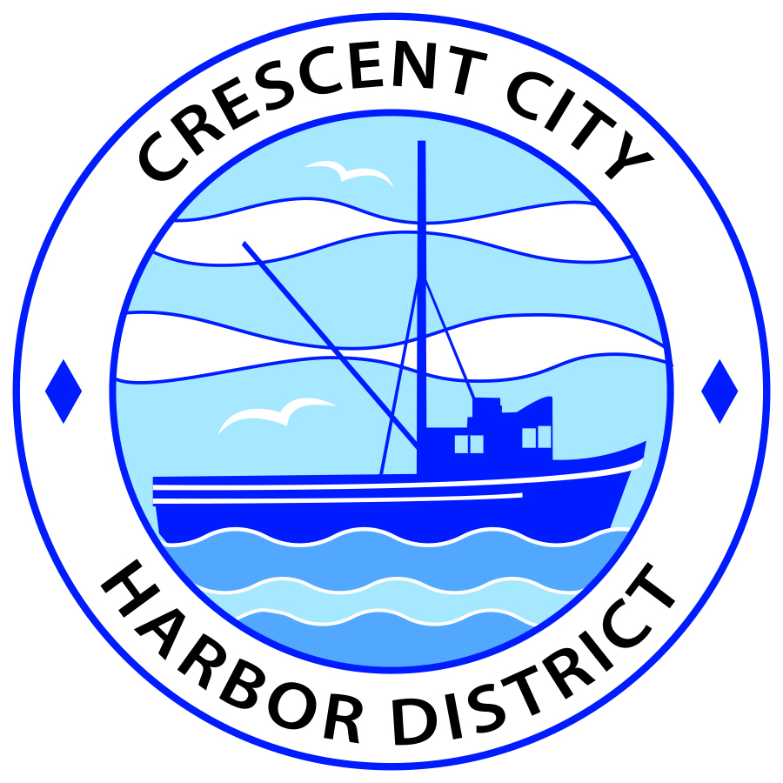
Regular Meeting
Board of Harbor Commissioners of the Crescent City Harbor District
James Ramsey, President Wes White, Secretary
Rick Shepherd, Commissioner Brian L. Stone, Commissioner, Carol White, Commissioner
AGENDA

Date: Tuesday, 20 August 2019

Time: Closed Session: 2:00 p.m.
Regular Session: 2:30 p.m.

Place: Crescent City Harbor District Meeting Room
101 Citizens Dock Road, Crescent City, CA 95531

Public participation in this meeting is encouraged and will be accommodated during the public comment period for each item on the agenda. The public will have an opportunity to speak on each item on the Agenda, but will be limited to a comment period of three minutes per item. The public comment period is not intended to be a question and answer session between members of the public and the Commission. The President of the Board of Harbor Commissioners or the Presiding Member of the Board of Harbor Commissioners may enforce, or for good cause extend, the three-minute time limit for each speaker.

Anyone requiring reasonable accommodation to participate in the meeting should contact the Harbor District at 707-464-6174 x 2 at least 48 hours prior to the meeting.

Call to Order

Roll Call

Pledge of Allegiance

Public Comment

This portion of the Agenda allows the public to comment to the Board on any issue not itemized on this Agenda. However, the Board may not take action or engage in discussion on any item that does not appear on the Agenda. Please limit comments to three minutes, and keep in mind that the public will have an opportunity to comment during the separate public comment period for every agenda item.
Closed Session
CONFERENCE WITH LEGAL COUNSEL – ANTICIPATED LITIGATION
Pursuant to subdivision (1) of paragraph (d) of Government Code Section 54956.9, there is significant exposure to litigation (1 case).

Report out of closed session.

Regular Session

- Consent Calendar

All items on this list are considered and acted on in one Motion. Anyone may request an item be removed from the Consent Agenda for separate consideration.
  - Approval of the warrant list since the 6 August, 2019 Harbor Commission Meeting

  - Approval of the minutes of the 6 August, 2019 Harbor Commission Meeting

- New Business

  - Presentation Regarding Relocation of Farmers’ Market to Crescent City Harbor District. Discuss and direct staff accordingly.

  - Review and Discuss New Travel Policy. Review and discuss possible updates to current policy. Direct staff accordingly.

  - Approve official travel for Charlie Helms and Mike Baker to attend the conference of the California Association of Harbor Masters and Port Captains. The conference will be held from September 3rd through September 6th, 2019, in Sacramento. The discounted room rate for conference attendees has been set at $189.00 per night. Discuss and approve.

  - Approve official travel for Mike Baker to attend EROS (Environmental Response to Oil Spills) training. The course will be held from October 22nd through October 24th, 2019, in Goleta, CA. The discounted nightly room rate for attendees has been set at $129.00 per night. Discuss and approve.

  - Discuss Date for Review of Updated Commissioner Bylaws. Staff proposes setting a special meeting for either November 5th or November 19th, 2019, at 12:00 p.m. to review and approve the updated bylaws.

  - Consider Cancellation of the Commissioners’ September 3rd, 2019 Meeting.

- Unfinished Business

  - Solar Project Update. Update on American Diversified Energy Solar Project.
  - Update on Measure C. The Harbor and the County are currently working on finalizing the necessary MOU.
  - Update on the Harbor Land Use Plan. The Land Use Plan was approved by the Harbor Commissioners and is currently pending County approval. The California Coastal Commission has already approved it.

- Communications and Reports

  - Financial Report.

  - CEO Report.

  - Commissioner Reports.
Pursuant to the Brown Act, this item allows the Commissioners to briefly discuss activities engaged in since the previous public meeting.

- Adjournment
  - E
Adjournment to the Board of Harbor Commissioners next regular meeting scheduled for Tuesday, August 20, 2019 at 2:00 P.M. at the Harbor District Office, 101 Citizens Dock Road, Crescent City, California.

