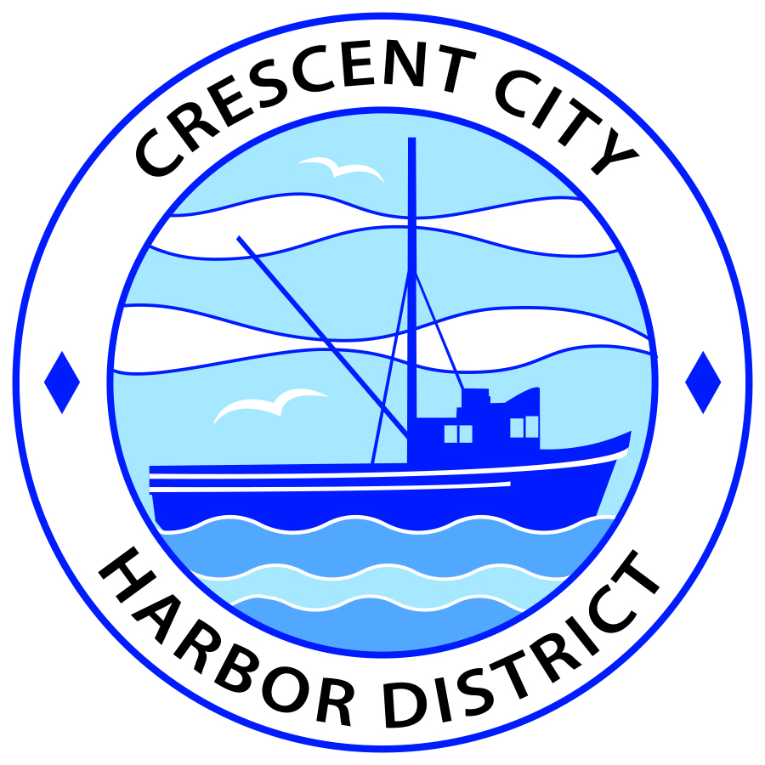
Board of Harbor Commissioners of the Crescent City Harbor District
James Ramsey, President Scott R. J. Feller, Secretary
Patrick A. Bailey, Commissioner Ronald A. Phillips, Commissioner Wes White, Commissioner

AGENDA
Board of Harbor Commissioners of the Crescent City Harbor District
At the Harbor District Office meeting room
101 Citizens Dock Road, Crescent City, California 95531

Regular Meeting Thursday, October 6, 2016 5:30 P.M.

The Board of Harbor Commissioners of the Crescent City Harbor District is now meeting in regular session. Only those items that indicate a specific time will be heard at the assigned time. All other items may be taken out of sequence to accommodate the public and staff availability.

5:30 p.m. The Board of Harbor Commissioners will meet in open session to discuss the following agenda items.

Pledge of Allegiance

Public Comment

Public comments are welcomed and encouraged by the Board. The President invites anyone in the audience to speak to the Board of Harbor Commissioners to identify themselves and the matter they wish to discuss. The Harbor Commission will then determine if such matters should be discussed at this time or scheduled for a subsequent meeting. As per the District’s bylaws, each speaker shall be limited to a maximum of three (3) minutes.

- Consent Agenda
Requests to remove items from the Consent Agenda may be heard at this time
- Approval of the warrant list since the September 20, 2016 Harbor Commission Special Meeting
- Approval of the minutes of the September 20, 2016 Harbor Commission Regular Meeting

- Presentation of lease for 128 Anchor Way. Review and approve document

- Presentation of lease for 191 Citizens Dock Road. Review and approve document

- Presentation on the RECARGO California Electric Highway Project license agreement for participation in their electric vehicle charging facility program. Review and discuss RECARGO proposal and determine if CCHD should participate

- Presentation of revised By-Laws and Conflict of Interest Policy for Friends of Crescent City Harbor. Review documentation and sign as appropriate

- Update for the Harbor Commissioners on the status of the solar power project. Hear presentation, review information and direct staff accordingly

- Discussion concerning investigating, selecting and contracting an RV Park consultant to develop conceptual plans for the Harbor RV Anchorage site and adjoining proposed tourist serving accommodations. Review information and direct staff to take appropriate action.

- Discussion about rescheduling or cancelling the November 1, 2016 Harbor Commission meeting. The Harbormaster will be out of town and unable to facilitate the meeting

- Presentation of Electrical Maintenance Services Contract. Review, approve, and direct chair to sign new electrical maintenance contract with Robert Colburn Electric, Inc.

- Commissioner Reports. Reports from Commissioners who represent the Harbor District on the Chamber of Commerce, Tri-Agency, Inter Governmental Relations Committee, Harbor Safety Committee and any other civic or community groups and from any current ad hoc committees

- CEO Report. Report on current and planned items

- Board Comments. The Agenda allows Board of Harbor Commission members the opportunity to discuss items of general interest, provide a reference or other resource to staff and to ask for clarification or request staff to report to the Board on certain matters

- Adjournment
*** Adjournment to the Board of Harbor Commissioners meeting scheduled for Tuesday, October 18, 2016 at 5:30 P.M. at the Harbor District Office, 101 Citizens Dock Road, Crescent City, California.

