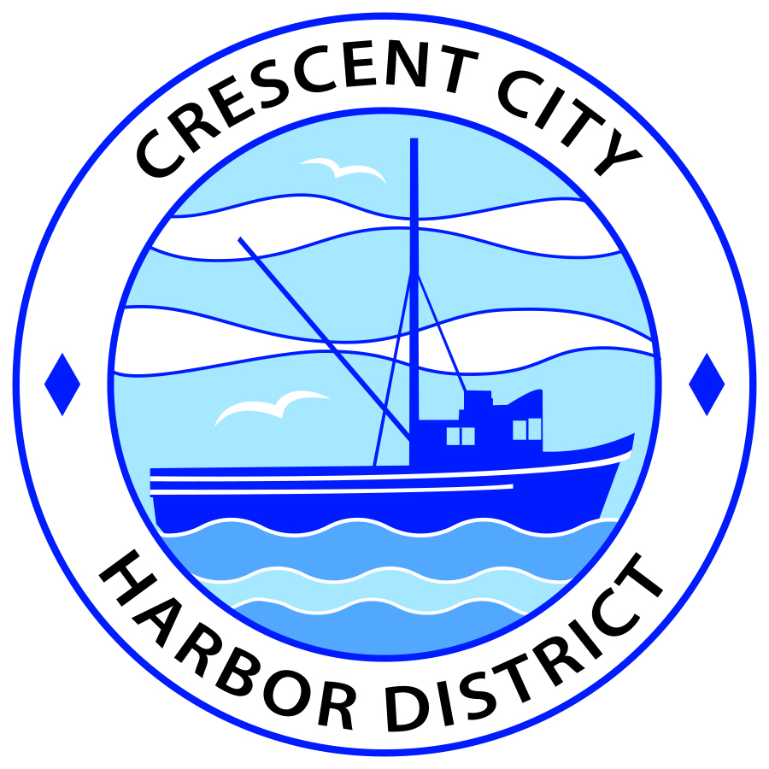
Board of Harbor Commissioners of the Crescent City Harbor District
James Ramsey, President George Wesley White, Secretary
Rick Shepherd, Commissioner; Brian L. Stone, Commissioner; Carol White, Commissioner
SPECIAL AGENDA

Date: Monday, 07, January, 2019

Time: Regular Session – 5:30 P.M.

Place: Crescent City Harbor District Meeting Room
101 Citizens Dock Road, Crescent City, CA 95531

Public participation in this meeting is encouraged and will be accommodated during the public comment period for each item on the agenda. The public will have an opportunity to speak on each item on the agenda, but will be limited to a comment period of three minutes per item. The public comment period is not intended to be a question and answer session between members of the public and the Commission. The President of the Board of Harbor Commissioners or the Presiding Member of the Board of Harbor Commissioners may enforce, or for good cause extend, the three minute time limit for each speaker.

Anyone requiring reasonable accommodation to participate in the meeting should contact the Harbor District at 707-464-6174 x 2 at least five (5) days prior to the meeting.

Call to Order Regular Session at 5:30 P.M.

Roll Call

Pledge of Allegiance

- Consent Calendar

Requests to remove items from the Consent Calendar may be heard at this time
a. Approval of the warrant list since the December 18, 2018, Harbor Commission Meeting
b. Approval of the meeting minutes of the December 18, 2018 Harbor Commission Meeting
2) New Business
a. Report of the Ad Hoc Budget Review Committee
Staff Summary: A copy of the mid-year financial report that was reviewed by the committee is attached
b. Proposed Harbor Commission Meeting dates for March 2019
Staff Summary: Discuss and approve the revised dates for the March Harbor Commission meetings:
- 12 March
- 26 March

c. Commissioners named to Community Boards and Organizations.
Staff Summary: President Ramsey named the following Harbor Commissioners to Community Boards and Organizations:
- James Ramsey Chamber of Commerce
- Wes White Visitors Bureau
- Wes White Tri-Agency
- Rick Shepherd Harbor Safety Committee
- Brian Stone Tri-Agency
- Brian Stone Oversight Committee
- Carol White Intergovernmental Relations Committee

- Unfinished Business

None at this time

Communications and Reports

Staff Reports
CEO Report Reports on Activities since prior meeting
Commissioners Reports on Activities since prior meeting

Adjournment

Adjournment to the Board of Harbor Commissioners next regular meeting scheduled for Tuesday, 5 February, 2019 at 5:30 P.M. at the Harbor District Office, 101 Citizens Dock Road, Crescent City, California.

