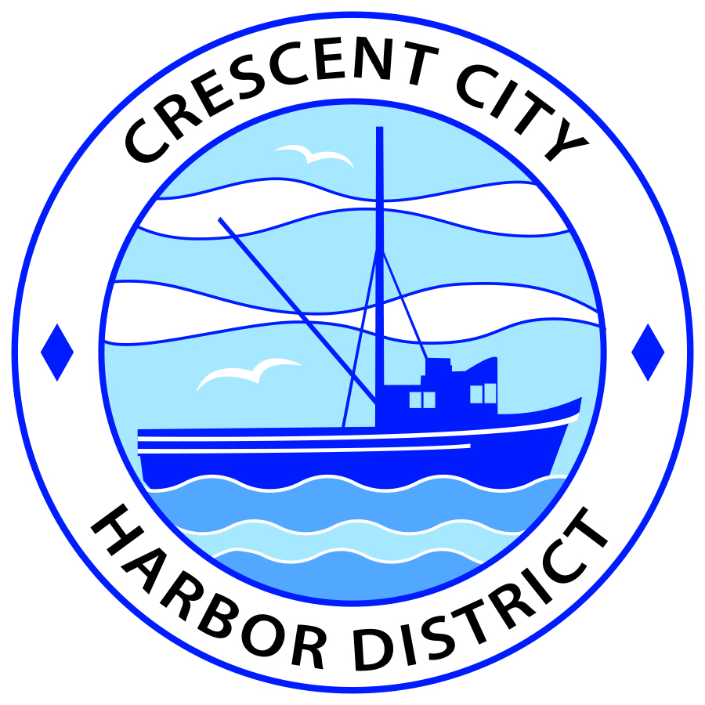
Board of Harbor Commissioners of the Crescent City Harbor District
Ronald A. Phillips, President Patrick A. Bailey, Secretary
James Ramsey, Commissioner Brian L. Stone, Commissioner Wes White, Commissioner

AGENDA
Board of Harbor Commissioners of the Crescent City Harbor District
At the Harbor District Office meeting room
101 Citizens Dock Road, Crescent City, California 95531

Regular Meeting Tuesday, March 21, 2017 5:30 P.M.

The Board of Harbor Commissioners of the Crescent City Harbor District is now meeting in regular session. Only those items that indicate a specific time will be heard at the assigned time. All other items may be taken out of sequence to accommodate the public and staff availability.

5:30 p.m. The Board of Harbor Commissioners will meet in open session to discuss the following agenda items.

Pledge of Allegiance

Public Comment

Public comments are welcomed and encouraged by the Board. The President invites anyone in the audience to speak to the Board of Harbor Commissioners to identify themselves and the matter they wish to discuss. The Harbor Commission will then determine if such matters should be discussed at this time or scheduled for a subsequent meeting. As per the District’s bylaws, each speaker shall be limited to a maximum of three (3) minutes.

- Consent Agenda
Requests to remove items from the Consent Agenda may be heard at this time
- Approval of the warrant list since the March 7, 2017 Harbor Commission Special Meeting
- Approval of the minutes of the March 7, 2017 Harbor Commission Regular Meeting
- Approval of the minutes for the March 16, 2017 Special Meeting of the Harbor Commission

- Extension of Coast Redwood Art Gallery rent reduction. Discuss, approve and direct staff accordingly

- Discussion and Review of fee schedule updates. Discuss, approve and direct staff accordingly.

- Review Harbor District asset position. Discuss and direct staff accordingly

- Discussion concerning Last Chance Grade. Discuss Last Chance Grade Situation

- Surplus Square Cash Control system. Discuss and direct staff action

- Update on Solar Power Project. Discuss the letter of intent and progress on the solar power project

- Presentation of Professional Services Agreement for Devin Jacot, electronic marketing consultant for the Crescent City Harbor District. Discuss, approve and direct staff as appropriate

- Pricing for Tiny Houses, Model Home and Yurts for Redwood Harbor Village. Discuss, approve and direct staff as appropriate

- Commissioner Reports. Reports from Commissioners who represent the Harbor District on the Chamber of Commerce, Tri-Agency, Inter Governmental Relations Committee, Harbor Safety Committee and any other civic or community groups and from any current ad hoc committees

- CEO Report. Report on current and planned items

- Board Comments. The Agenda allows Board of Harbor Commission members the opportunity to discuss items of general interest, provide a reference or other resource to staff and to ask for clarification or request staff to report to the Board on certain matters

- Adjournment
*** Adjournment to the Board of Harbor Commissioners meeting scheduled for Tuesday, April 4, 2017 at 5:30 P.M. at the Harbor District Office, 101 Citizens Dock Road, Crescent City, California.

