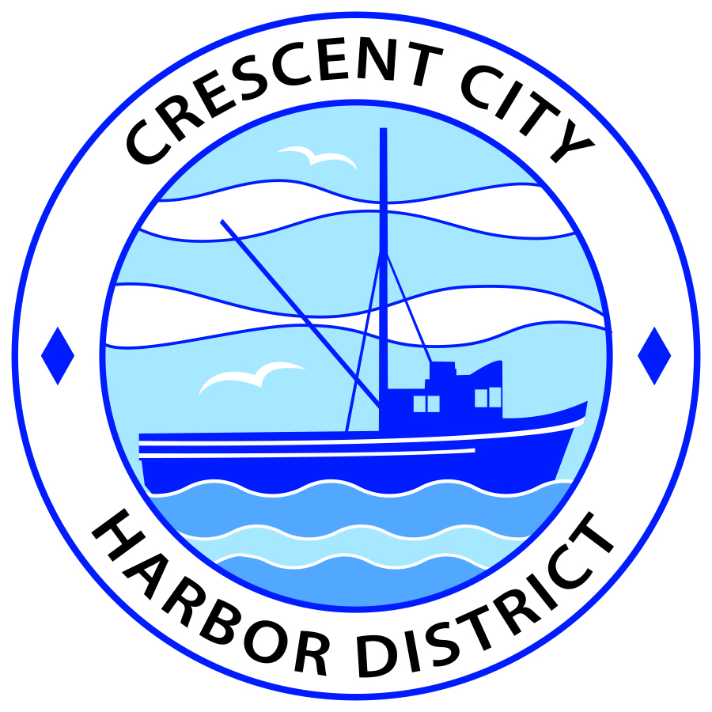
Board of Harbor Commissioners of the Crescent City Harbor District
James Ramsey, President Scott R. J. Feller, Secretary
Patrick A. Bailey, Commissioner Ronald A. Phillips, Commissioner Wes White, Commissioner

AGENDA
Board of Harbor Commissioners of the Crescent City Harbor District
At the Harbor District Office meeting room
101 Citizens Dock Road, Crescent City, California 95531

Regular Meeting Tuesday, September 6, 2016 5:30 P.M.

The Board of Harbor Commissioners of the Crescent City Harbor District is now meeting in regular session. Only those items that indicate a specific time will be heard at the assigned time. All other items may be taken out of sequence to accommodate the public and staff availability.

5:30 p.m. The Board of Harbor Commissioners will meet in open session to discuss the following agenda items.

Pledge of Allegiance

Public Comment prior to closed session.

Adjourn to Closed Session. The Board of Harbor Commissioners will now meet in closed session to discuss the following items:

- CONFERENCE WITH REAL PROPERTY NEGOTIATIONS: Pursuant to Government Code Section 54956.8 Property 128 Anchor Way, Crescent City, Agency Negotiator: Charles Helms

Report Out of Closed Session
5:45 p.m. The Board of Harbor Commissioners will meet in open session to discuss the following agenda items
Public Comment

Public comments are welcomed and encouraged by the Board. The President invites anyone in the audience to speak to the Board of Harbor Commissioners to identify themselves and the matter they wish to discuss. The Harbor Commission will then determine if such matters should be discussed at this time or scheduled for a subsequent meeting. As per the District’s bylaws, each speaker shall be limited to a maximum of three (3) minutes.

- Consent Agenda

Requests to remove items from the Consent Agenda may be heard at this time
- Approval of the warrant list since the August 16, 2016 Harbor Commission Special Meeting
- Approval of the minutes of the August 16, 2016 Harbor Commission Regular Meeting

- Update for the Harbor Commissioners on the status of the solar power project. Review information and direct staff

- Presentation of corporate documentation and Conflict of Interest Statement for the Friends of the Crescent City Harbor District. Review documentation, approve and direct staff accordingly

- Presentation of documentation from United States Coast Guard Notice of Option to Renew Lease. Take action as necessary and appropriate

- Discussion concerning investigating, selecting and contracting an RV Park consultant to develop conceptual plans for the Harbor RV Anchorage site and adjoining proposed tourist serving accommodations. Review information and direct staff to take appropriate action.

- Discussion about a Resolution authorizing the Harbor District to enter into an MOU with Del Norte County authorizing participation in the County’s Administrative Law hearings. Discuss and take action as necessary and appropriate

- Discussion of Harbor District refund procedure for individuals seeking to leave the marina before the term for which they have paid. Discuss and direct staff to take appropriate action.

- Commissioner Reports. Reports from Commissioners who represent the Harbor District on the Chamber of Commerce, Tri-Agency, Inter Governmental Relations Committee, Harbor Safety Committee and any other civic or community groups and from any current ad hoc committees

- CEO Report. Report on current and planned items

- Board Comments. The Agenda allows Board of Harbor Commission members the opportunity to discuss items of general interest, provide a reference or other resource to staff and to ask for clarification or request staff to report to the Board on certain matters

- Adjournment
*** Adjournment to the Board of Harbor Commissioners meeting scheduled for Tuesday, September 20, 2016 at 5:30 P.M. at the Harbor District Office, 101 Citizens Dock Road, Crescent City, California.

