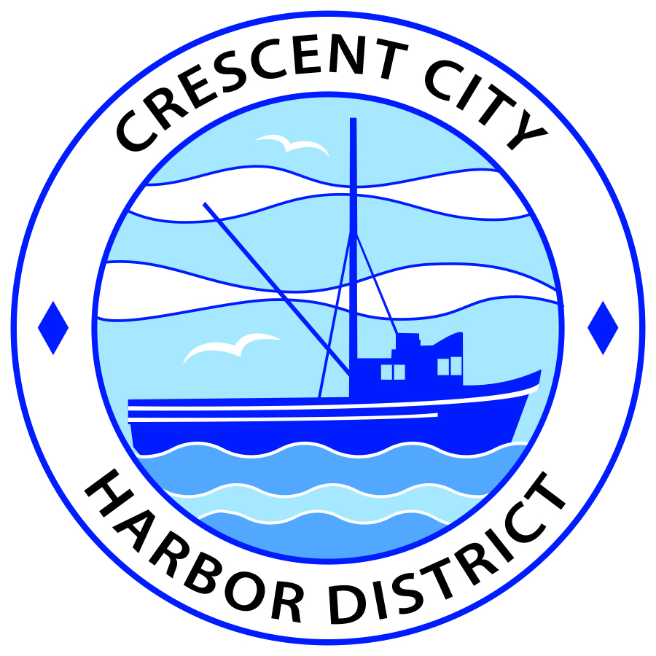
Board of Harbor Commissioners of the Crescent City Harbor District
Patrick A. Bailey, President James Ramsey, Secretary
Ronald A. Phillips, Commissioner Brian L. Stone, Commissioner Wes White, Commissioner
AGENDA
Board of Harbor Commissioners of the Crescent City Harbor District
At the Harbor District Office Meeting Room
101 Citizens Dock Road, Crescent City, California 95531

Regular Meeting Tuesday, February 20, 2018 5:30 P.M.

The Board of Harbor Commissioners of the Crescent City Harbor District is now meeting in regular session. Only those items that indicate a specific time will be heard at the assigned time. All other items may be taken out of sequence to accommodate the public and staff availability.

5:30 p.m. The Board of Harbor Commissioners will meet in open session to discuss the following agenda items.

Pledge of Allegiance

Public Comment

Public comments are welcomed and encouraged by the Board. The President invites anyone in the audience to speak to the Board of Harbor Commissioners to identify themselves and the matter they wish to discuss. The Harbor Commission will then determine if such matters should be discussed at this time or scheduled for a subsequent meeting. As per the District’s bylaws, each speaker shall be limited to a maximum of three (3) minutes.

- Consent Agenda
Requests to remove items from the Consent Agenda may be heard at this time
- Approval of the warrant list since the February 06, 2018 Harbor Commission Meeting
- Approval of the minutes of the February 06, 2018 Harbor Commission Meeting

- Presentation of Solar placement and design options for the Harbor District.
Review options, discuss and direct staff

- Discussion concerning how to address and plan for funding the approximate $11 million in needed Harbor repairs. Discuss options and strategies

- Discus the option of the Crescent City Harbor District sponsoring the Friends of the Harbor Pirate Festival scheduled for 7 April 2018 when the Tall Ships are in the marina, so that the Harbor District’s Liability Insurance coverage is in effect for this event. Discuss, decide and direct staff on how to proceed.

- Disclose Board assignments for Chamber of Commerce, Visitor’s bureau, Tri-Agency, IGRC, Harbor Safety and any other appropriate community committees. Review and Discuss

- Share Board assignments for ad hoc Budget and Labor Negotiation Committees.
Discuss and direct staff accordingly.

- Discuss response to Request for Proposals for Professional Polling/Public Opinion Research Services. Discuss and potentially award professional services contract for Professional Polling services and direct staff to follow up on Commission action.

- Discussion of Harbor Debt situation, report on conversations regarding options for addressing debt challenges and options for Harbor fundraising. Review, discuss strategy and direct staff if action is needed

- Discuss scheduling an orientation and training session for Harbor District notebook use. Discuss and select a date for session.

- Discuss and review edits to audit report for FY 2016-2017. Review edits, discuss and approve audit report.

- CEO Report

- Commissioner Reports. Reports from Commissioners who represent the Harbor District on the Chamber of Commerce, Tri-Agency, Inter Governmental Relations Committee, Harbor Safety Committee and any other civic or community groups and from any current ad hoc committees.

- Board Comments. The Agenda allows Board of Harbor Commission members the opportunity to discuss items of general interest, provide a reference or other resource to staff and to ask for clarification or request staff to report to the Board on certain matters.

- Adjournment
*** Adjournment to the Board of Harbor Commissioners meeting scheduled for Tuesday March 6, 2018 at 5:30 P.M. at the Harbor District Office, 101 Citizens Dock Road, Crescent City, California.

