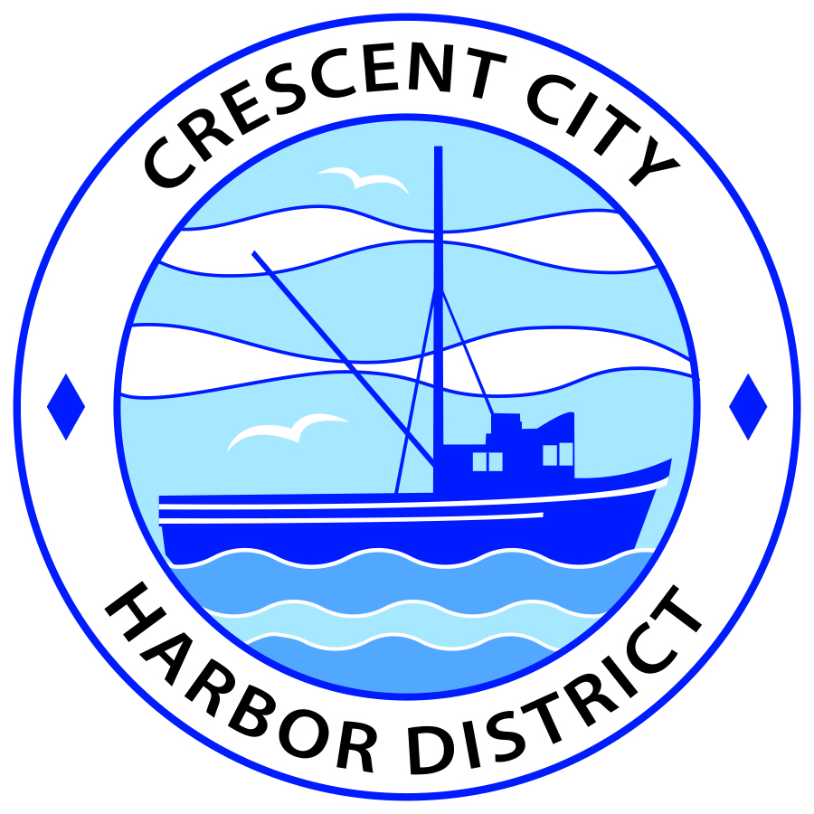
Board of Harbor Commissioners of the Crescent City Harbor District
Ronald A. Phillips, President Patrick A. Bailey, Secretary
James Ramsey, Commissioner Brian L. Stone, Commissioner Wes White, Commissioner

AGENDA
Board of Harbor Commissioners of the Crescent City Harbor District
At the Harbor District Office meeting room
101 Citizens Dock Road, Crescent City, California 95531

Regular Meeting Tuesday, January 16, 2018 5:30 P.M.

The Board of Harbor Commissioners of the Crescent City Harbor District is now meeting in regular session. Only those items that indicate a specific time will be heard at the assigned time. All other items may be taken out of sequence to accommodate the public and staff availability.

5:30 p.m. The Board of Harbor Commissioners will meet in open session to discuss the following agenda items.

Pledge of Allegiance

Public Comment

Public comments are welcomed and encouraged by the Board. The President invites anyone in the audience to speak to the Board of Harbor Commissioners to identify themselves and the matter they wish to discuss. The Harbor Commission will then determine if such matters should be discussed at this time or scheduled for a subsequent meeting. As per the District’s bylaws, each speaker shall be limited to a maximum of three (3) minutes.

- Consent Agenda
Requests to remove items from the Consent Agenda may be heard at this time
- Approval of the warrant list since the January 5, 2018 Harbor Commission Meeting
- Approval of the minutes of the January 5, 2018 Harbor Commission Meeting

- Approve Land Use Plan Update. Discuss, approve and direct staff to send updated Land Use Plan to Del Norte County and City Of Crescent City for official approval

- Review rrm design group proposal to update Harbor Master Plan Graphic to conform to updated Land Use Plan. Review proposal, discuss and approve update

- Review and authorize Acknowledgment and Consent to Assignment Agreement. Review and approve Renewable Energy Capital agreement with the Harbor District of the assignment as part of the solar project financing to American Diversified Energy for construction financing.

- Approve Resolution 2018-001 declaring that the Crescent City Harbor District elects to be subject to the uniform public construction cost accounting procedures applicable in the State of California. The Harbor District has been operating in compliance with the above mentioned procedures, but the State Controller did not have an original copy on file

- Review Draft FY 2016-2017 Audit report. Review, discuss and approve audit report

- Discussion of Harbor Debt situation, report on conversations regarding options for addressing debt challenges and options for Harbor fundraising. Discuss and direct staff accordingly.

- CEO Report

- Commissioner Reports. Reports from Commissioners who represent the Harbor District on the Chamber of Commerce, Tri-Agency, Inter Governmental Relations Committee, Harbor Safety Committee and any other civic or community groups and from any current ad hoc committees

- Board Comments. The Agenda allows Board of Harbor Commission members the opportunity to discuss items of general interest, provide a reference or other resource to staff and to ask for clarification or request staff to report to the Board on certain matters

- Adjournment
*** Adjournment to the Board of Harbor Commissioners meeting scheduled for Tuesday, February 6, 2018 at 5:30 P.M. at the Harbor District Office, 101 Citizens Dock Road, Crescent City, California.

