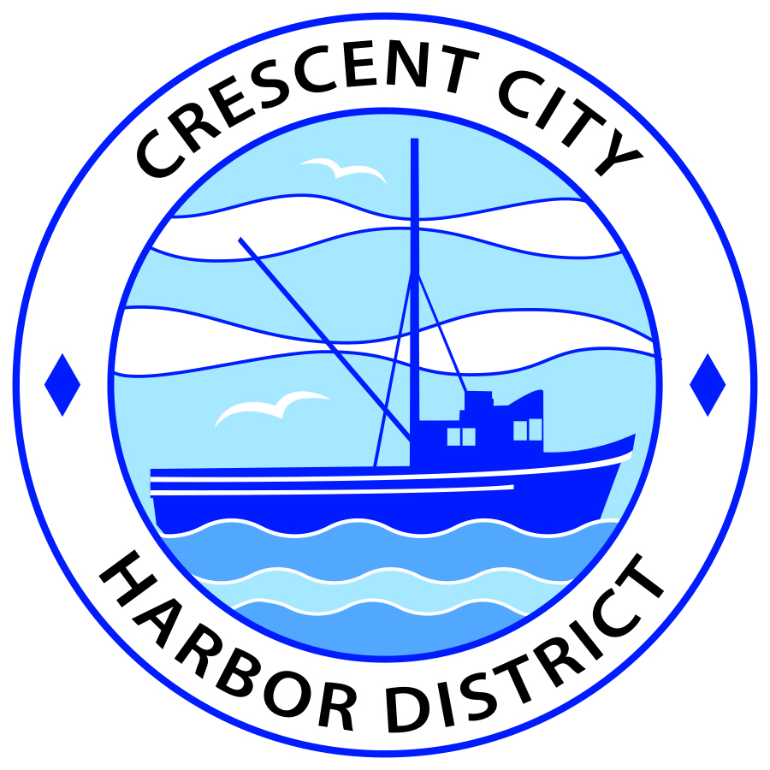
Regular Meeting
Board of Harbor Commissioners of the Crescent City Harbor District
James Ramsey, President Wes White, Secretary
Rick Shepherd, Commissioner Brian L. Stone, Commissioner, Carol White, Commissioner
AGENDA

Date: Tuesday, 2 July, 2019

Time: Regular Session: 2:00 p.m.

Place: Crescent City Harbor District Meeting Room
101 Citizens Dock Road, Crescent City, CA 95531

Public participation in this meeting is encouraged and will be accommodated during the public comment period for each item on the agenda. The public will have an opportunity to speak on each item on the Agenda, but will be limited to a comment period of three minutes per item. The public comment period is not intended to be a question and answer session between members of the public and the Commission. The President of the Board of Harbor Commissioners or the Presiding Member of the Board of Harbor Commissioners may enforce, or for good cause extend, the three-minute time limit for each speaker.

Anyone requiring reasonable accommodation to participate in the meeting should contact the Harbor District at 707-464-6174 x 2 at least 48 hours prior to the meeting.

Call to Order

Roll Call

Pledge of Allegiance

Public Comment

This portion of the Agenda allows the public to comment to the Board on any issue not itemized on this Agenda. However, the Board may not take action or engage in discussion on any item that does not appear on the Agenda. Please limit comments to three minutes, and keep in mind that the public will have an opportunity to comment during the separate public comment period for every agenda item.
Regular Session
- Consent Calendar

All items on this list are considered and acted on in one Motion. Anyone may request an item be removed from the Consent Agenda for separate consideration.
  - Approval of the warrant list since the 18 June, 2019 Harbor Commission Meeting
  - Approval of the minutes of the 18 June, 2019 Harbor Commission Meeting

- New Business

  - Distribution of the proposed Employee Handbook for Commission review. No action will be taken at this meeting. Adoption in whole or part will be addressed at a subsequent meeting. The Harbor District subscribes to the California Chamber of Commerce Human Resource services and this is the latest update from the Cal Chamber.

  - Approve the Harbor District Operating Budget following the thirty day public review period. The Harbor Commissioners approved the budget 2019-2020 Operating Budget proposal and directed staff to place the budget document out for thirty day public review. The review period has expired and no negative comments were received.

  - Approve lease amendment for Crescent Seafood. The amendment updates lease terms from percentage rent to a price per square foot lease.

  - Review new dog leash and parking ordinances from the City of Crescent City. No action will be taken at this meeting. Commissioners will be asked to review the City’s ordinances and the existing Harbor District ordinances addressing the same issues. At a subsequent meeting, the Harbor Commissioners will direct Staff on how to proceed concerning any ordinance updates related to dog leash or parking.

  - Report from Friends of the Harbor about upcoming scheduled fund raising activities at the Harbor District. Review and discuss

- Unfinished Business

  - Solar Project Update. Update on American Diversified Energy Solar Project.

- Communications and Reports

  - CEO Report.

  - Commissioner Reports.
Pursuant to the Brown Act, this item allows the Commissioners to briefly discuss activities engaged in since the previous public meeting.

- Adjournment
  - E
Adjournment to the Board of Harbor Commissioners next regular meeting scheduled for Tuesday, 16 July, 2019 at 2:00 P.M. at the Harbor District Office, 101 Citizens Dock Road, Crescent City, California.

