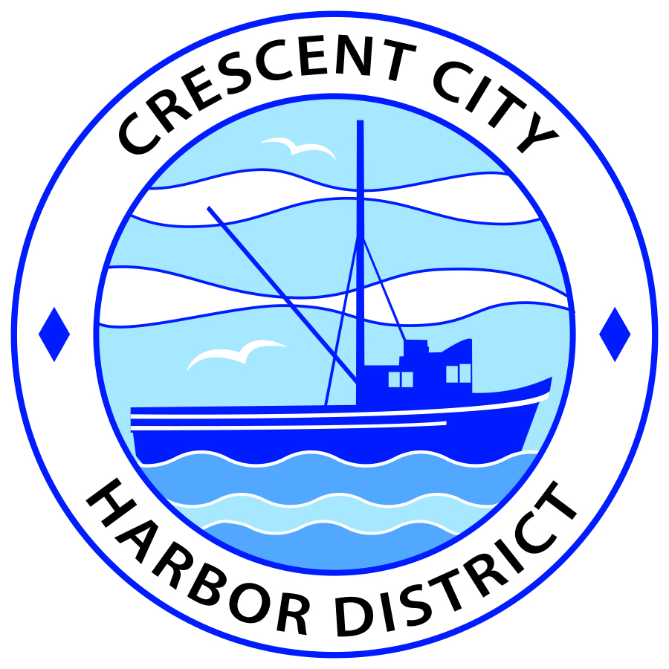
Regular Meeting
Board of Harbor Commissioners of the Crescent City Harbor District
James Ramsey, President Wes White, Secretary
Rick Shepherd, Commissioner Brian L. Stone, Commissioner, Carol White, Commissioner
AGENDA

Date: Tuesday, 1 October, 2019

Time: Closed Session: 2:00 p.m.
Regular Session: 2:30 p.m.

Place: Crescent City Harbor District Meeting Room
101 Citizens Dock Road, Crescent City, CA 95531

Public participation in this meeting is encouraged and will be accommodated during the public comment period for each item on the agenda. The public will have an opportunity to speak on each item on the Agenda, but will be limited to a comment period of three minutes per item. The public comment period is not intended to be a question and answer session between members of the public and the Commission. The President of the Board of Harbor Commissioners or the Presiding Member of the Board of Harbor Commissioners may enforce, or for good cause extend, the three-minute time limit for each speaker.

Anyone requiring reasonable accommodation to participate in the meeting should contact the Harbor District at 707-464-6174 x 2 at least 48 hours prior to the meeting.

Call to Order

Roll Call

Pledge of Allegiance

Public Comment

This portion of the Agenda allows the public to comment to the Board on any issue not itemized on this Agenda. However, the Board may not take action or engage in discussion on any item that does not appear on the Agenda. Please limit comments to three minutes, and keep in mind that the public will have an opportunity to comment during the separate public comment period for every agenda item.
Closed Session
PUBLIC EMPLOYEE PERFORMANCE EVALUATION (CEO / HARBOR MASTER)
Pursuant to subdivision (1) of paragraph (b) of Government Code § 54957, the evaluation of the performance of a public employee is being considered (CEO / Harbor Master)

Report out of closed session.

Regular Session

- Consent Calendar

All items on this list are considered and acted on in one Motion. Anyone may request an item be removed from the Consent Agenda for separate consideration.
  - Approval of the warrant list since the 24 September, 2019 Harbor Commission Meeting

  - Approval of the minutes of the 24 September, 2019 Harbor Commission Meeting

- New Business

  - Demolition and Recycling of the vessel “Christie R.” Consider proposal previously received from Global Diving and Salvage, Inc., along with new proposal from Fashion Blacksmith, Inc., to perform demolition and recycling of the remaining portion of the vessel “Christie R.” Choose the desired vendor and direct staff to prepare an appropriate contract in consultation with Harbor Counsel. Review, discuss, and approve.

  - Consider approaching Harbor restaurants regarding listing on the Surfrider Foundation “Ocean Friendly” restaurant list. Staff proposes a one-time lease reduction to cover the cost of membership (up to $150 per restaurant). Review, discuss, and approve.

  - Bayside RV Park Logo. Review, discuss and direct staff.

  - Review printing quotes for Harbor brochure. Harbor staff received 3 quote to print the brochure Review, discuss and approve.

- Unfinished Business

- Agreement with the County of Del Norte regarding Measure “C”. Consider a revised draft agreement negotiated by Harbor Counsel that establishes how the Harbor and the County of Del Norte will implement Measure “C”. Review, discuss, and approve.

- Harbor Facilities Plan. Review the final Harbor Facilities Plan and approve posting for a 30-day public comment period in accordance with Measure “C”. Review, discuss, and approve.

- Communications and Reports

  - A.D.E. Solar Update

  - CEO Report.

  - Commissioner Reports.
Pursuant to the Brown Act, this item allows the Commissioners to briefly discuss activities engaged in since the previous public meeting.

- Adjournment
  - E
Adjournment to the Board of Harbor Commissioners next regular meeting scheduled for Tuesday, October 15, 2019 at 2:00 P.M. at the Harbor District Office, 101 Citizens Dock Road, Crescent City, California.

