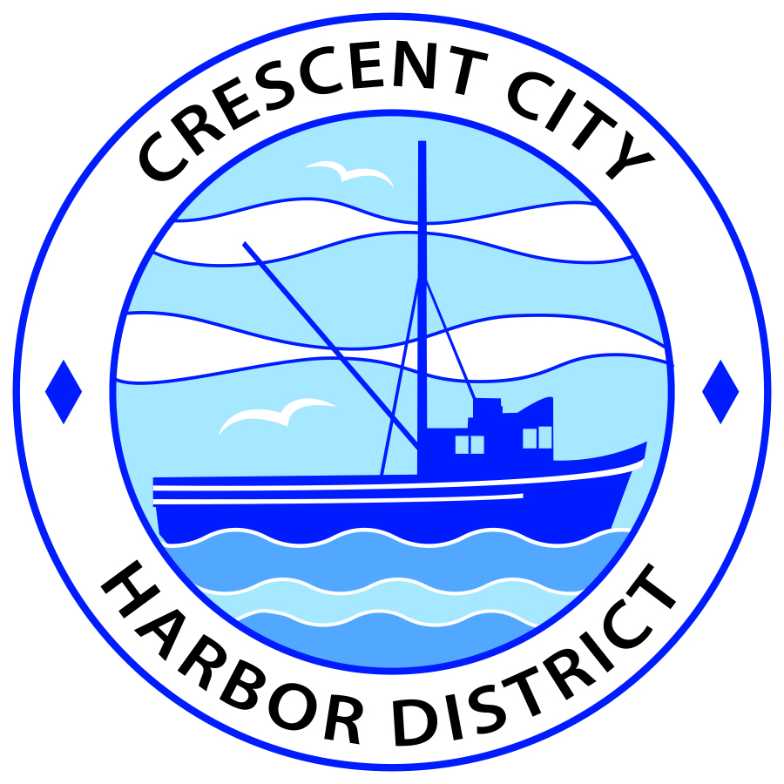
Board of Harbor Commissioners of the Crescent City Harbor District
Ronald A. Phillips, President Patrick A. Bailey, Secretary
James Ramsey, Commissioner Brian L. Stone, Commissioner Wes White, Commissioner

SPECIAL MEETING AGENDA
Board of Harbor Commissioners of the Crescent City Harbor District
At the Harbor District Office meeting room
101 Citizens Dock Road, Crescent City, California 95531

Special Meeting Tuesday, July 11, 2017 5:00 P.M.

The Board of Harbor Commissioners of the Crescent City Harbor District is now meeting in regular session. Only those items that indicate a specific time will be heard at the assigned time. All other items may be taken out of sequence to accommodate the public and staff availability.

5:00 p.m. The Board of Harbor Commissioners will meet in open session to discuss the following agenda items.

Pledge of Allegiance

Public Comment

Public comments are welcomed and encouraged by the Board. The President invites anyone in the audience to speak to the Board of Harbor Commissioners to identify themselves and the matter they wish to discuss. The Harbor Commission will then determine if such matters should be discussed at this time or scheduled for a subsequent meeting. As per the District’s bylaws, each speaker shall be limited to a maximum of three (3) minutes.

- Discussion and Direction concerning next steps to address Harbor Debt Reduction.
The Board of Harbor Commissioners will discuss the report that they directed Harbormaster Helms to prepare with the input of SCI Consultants on the analysis of potential Harbor Debt Reduction actions

- Commissioner Patrick A. Bailey will address the Commission to propose setting up tent camping facilities along the tree line behind the temporary fish cleaning station on Starfish Way. The Board of Harbor Commissioners will discuss Commissioner Bailey’s proposal and suggest appropriate action

- Board Comments. The Agenda allows Board of Harbor Commission members the opportunity to discuss items of general interest, provide a reference or other resource to staff and to ask for clarification or request staff to report to the Board on certain matters

- Adjournment
*** Adjournment to the Board of Harbor Commissioners meeting scheduled for Tuesday, July 18, 2017 at 5:30 P.M. at the Harbor District Office, 101 Citizens Dock Road, Crescent City, California.

