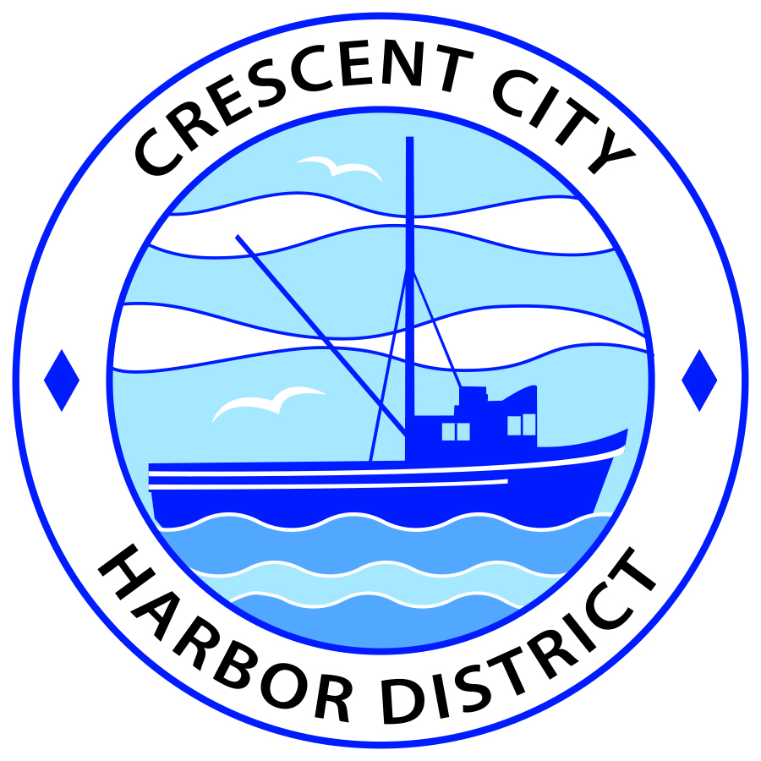
Board of Harbor Commissioners of the Crescent City Harbor District
James Ramsey, President Scott R. J. Feller, Secretary
Patrick A. Bailey, Commissioner Ronald A. Phillips, Commissioner Wes White, Commissioner

AGENDA
Board of Harbor Commissioners of the Crescent City Harbor District
At the Harbor District Office meeting room
101 Citizens Dock Road, Crescent City, California 95531

Regular Meeting Tuesday, November 1, 2016 5:30 P.M.

The Board of Harbor Commissioners of the Crescent City Harbor District is now meeting in regular session. Only those items that indicate a specific time will be heard at the assigned time. All other items may be taken out of sequence to accommodate the public and staff availability.

5:30 p.m. The Board of Harbor Commissioners will meet in open session to discuss the following agenda items.

Pledge of Allegiance

Public Comment

Public comments are welcomed and encouraged by the Board. The President invites anyone in the audience to speak to the Board of Harbor Commissioners to identify themselves and the matter they wish to discuss. The Harbor Commission will then determine if such matters should be discussed at this time or scheduled for a subsequent meeting. As per the District’s bylaws, each speaker shall be limited to a maximum of three (3) minutes.

- Consent Agenda
Requests to remove items from the Consent Agenda may be heard at this time
- Approval of the warrant list since the October 18, 2016 Harbor Commission Special Meeting
- Approval of the minutes of the October 18, 2016 Harbor Commission Regular Meeting

- Presentation concerning Coast Redwoods Art Association lease extension. Discuss and direct staff accordingly

- Update and presentation concerning electronic communications with elected officials . Discuss and direct staff to proceed accordingly

- Overview of security camera placement at Inner Boat Basin. Review data and direct staff accordingly

- Presentation of solar power project progress. Discuss progress on project and direct staff accordingly

- Discussion concerning moving Harbor Commission meetings back to Flynn Center. Discuss and direct staff to proceed accordingly.

- Presentation of copier replacement options. Review options and direct staff actions.

- Commissioner Reports. Reports from Commissioners who represent the Harbor District on the Chamber of Commerce, Tri-Agency, Inter Governmental Relations Committee, Harbor Safety Committee and any other civic or community groups and from any current ad hoc committees

- CEO Report. Report on current and planned items

- Board Comments. The Agenda allows Board of Harbor Commission members the opportunity to discuss items of general interest, provide a reference or other resource to staff and to ask for clarification or request staff to report to the Board on certain matters

- Adjournment
*** Adjournment to the Board of Harbor Commissioners meeting scheduled for Tuesday, November 15, 2016 at 5:30 P.M. at the Harbor District Office, 101 Citizens Dock Road, Crescent City, California.

