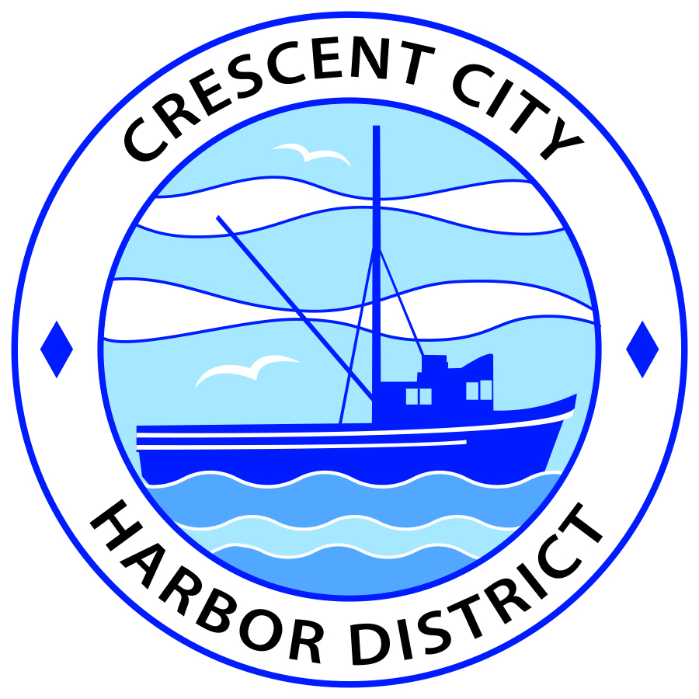
Special Meeting
Board of Harbor Commissioners of the Crescent City Harbor District
James Ramsey, President Wes White, Secretary
Rick Shepherd, Commissioner Brian L. Stone, Commissioner, Carol White, Commissioner

SPECIAL MEETING
AGENDA

Date: Thursday, February 28, 2019

Time: 1:00 p.m.

Place: Crescent City Harbor District Meeting Room
101 Citizens Dock Road, Crescent City, CA 95531

Public participation in this meeting is encouraged and will be accommodated during the public comment period for each item on the agenda. The public will have an opportunity to speak on each item on the Agenda, but will be limited to a comment period of three minutes per item. The public comment period is not intended to be a question and answer session between members of the public and the Commission. The President of the Board of Harbor Commissioners or the Presiding Member of the Board of Harbor Commissioners may enforce, or for good cause extend, the three-minute time limit for each speaker.

Anyone requiring reasonable accommodation to participate in the meeting should contact the Harbor District at 707-464-6174 x 2 at least 48 hours prior to the meeting.

Call to Order

Roll Call

Pledge of Allegiance

Public Comment

This portion of the meeting allows the public to comment to the Board on any issue not itemized on this agenda. However the Board may not take action or engage in discussion on any item that does not appear on the agenda. Please limit comments to three minutes and keep in mind that the public will have an opportunity to comment during the separate comment period for every agenda item.

New Business

- Approve and sign the support letter requested by Congressman Huffman to the California Transportation Commission to fully fund the Project Approval and Environmental Document phase of the Last Chance Grade project. The letter is attached to this agenda item
- Discuss and approve the Harbor District’s percentage of support for the Tri-Agency Economic Development Authority. Tri-Agency Harbor representatives Secretary White and Commissioner Stone will present this topic.

Adjournment
  - E
Adjournment to the Board of Harbor Commissioners next regular meeting scheduled for Tuesday, March 13, 2019 at 5:00 P.M. at the Harbor District Office, 101 Citizens Dock Road, Crescent City, California.

