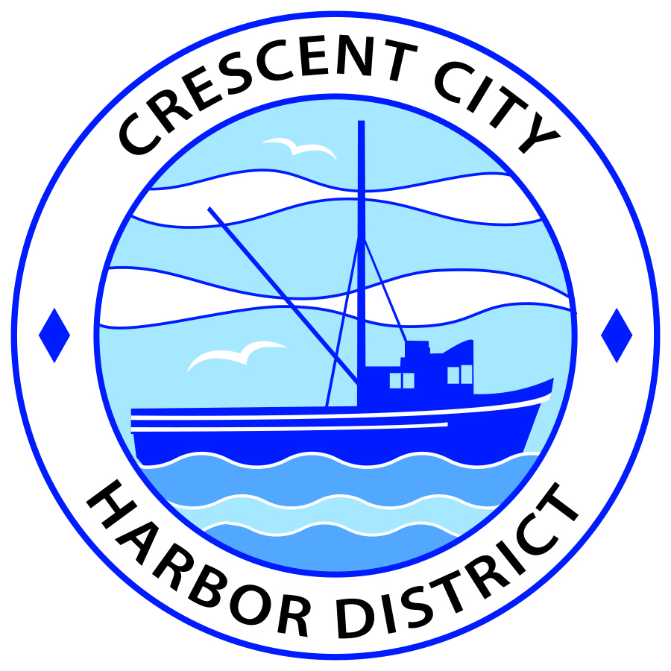
Board of Harbor Commissioners of the Crescent City Harbor District
Patrick A. Bailey, President James Ramsey, Secretary
Ronald A. Phillips, Commissioner Brian L. Stone, Commissioner Wes White, Commissioner
AGENDA
Board of Harbor Commissioners of the Crescent City Harbor District
At the Harbor District Office Meeting Room
101 Citizens Dock Road, Crescent City, California 95531

Regular Meeting Tuesday, 17 July, 2018 5:30 P.M.

The Board of Harbor Commissioners of the Crescent City Harbor District is now meeting in regular session. Only those items that indicate a specific time will be heard at the assigned time. All other items may be taken out of sequence to accommodate the public and staff availability. Anyone requiring reasonable accommodation to participate in the meeting should contact the Harbor District at 707-464-6174 x 2 at least five (5) days prior to the meeting.

5:30 p.m. The Board of Harbor Commissioners will meet in open session to discuss the following agenda items.

Pledge of Allegiance

Public Comment

Public comments are welcomed and encouraged by the Board. The President invites anyone in the audience to speak to the Board of Harbor Commissioners to identify themselves and the matter they wish to discuss. The Harbor Commission will then determine if such matters should be scheduled for a subsequent meeting. As per the District’s bylaws, each speaker shall be limited to a maximum of three (3) minutes.

- Consent Agenda
Requests to remove items from the Consent Agenda may be heard at this time
- Approval of the warrant list since the 15 May, 2018, Harbor Commission Meeting
- Approval of the minutes of the 15 May, 2018 Harbor Commission Meeting
- Approval of the minutes of the 31 May, 2018 Harbor Commission Meeting
- Approval of the minutes of the 11 July,2018 Harbor Commission Meeting

- Discuss hosting the Farmer’s Market at the Harbor District during Del Norte County Fair week. Discuss and approve

- Discussion to approve sending letters of gratitude to the Wild Rivers Community Foundation Funders and the Friends of the Crescent City Harbor for funding the Harbor Master’s Site Visit to Rikuzentakata, Japan. Approve appreciation letters and sign.

- Discuss approval of placing a memorial bench honoring Leonard ‘Buddy’ Wilson, long term commercial fisherman tenant of the Harbor District, on Harbor Promenade. Review proposal and approve

- Discuss leasing a 15,000 pound capacity forklift to replace the Wiggins forklift. Discuss pricing options and approve acquisition of heavy duty forklift.

- Discuss retaining ‘Crescent City’ sign that was installed at South Beach deck. Discuss potential safety issues with existing deck and costs to remedy safety issues and approve new platform/deck construction and retention of sign.

- Update and discussion of progress on solar power at the Harbor District with American Diversified Energy representatives. Review, discuss and direct staff accordingly

- Presentation concerning wind power by Jean Thurston, U.S. Bureau of Ocean Energy Management; Christopher Potter, California Natural Resources Agency; and Eric Wilkins, California Department of Fish and Wildlife. Listen to presentation and discuss as needed

- Update on the progress of the Citizens Initiative addressing the Harbor District debt situation. Listen to presentation and Discuss

- Discussion of Harbor District debt situation and options for fundraising to meet debt challenge. Review, discuss strategy and direct staff if action is needed

- CEO Report

- Commissioner Reports. Reports from Commissioners who represent the Harbor District on the Chamber of Commerce, Tri-Agency, Inter Governmental Relations Committee, Harbor Safety Committee and any other civic or community groups and from any current ad hoc committees.

- Board Comments. The Agenda allows Board of Harbor Commission members the opportunity to discuss items of general interest, provide a reference or other resource to staff and to ask for clarification or request staff to report to the Board on certain matters.

- Adjournment
*** Adjournment to the Board of Harbor Commissioners meeting scheduled for Tuesday August 07, 2018 at 5:30 P.M. at the Harbor District Office, 101 Citizens Dock Road, Crescent City, California.

.

