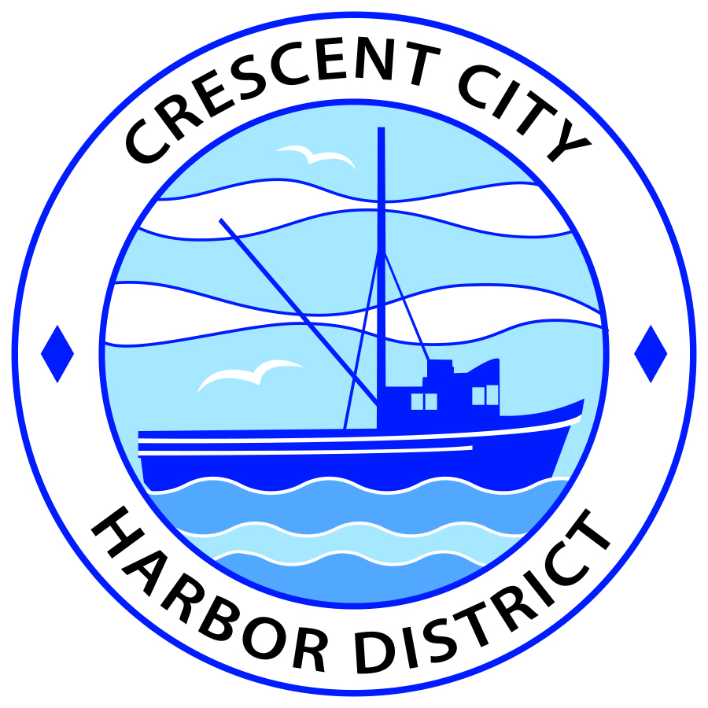
Agenda
Board of Harbor Commissioners of the Crescent City Harbor District
James Ramsey, President Wes White, Secretary
Rick Shepherd, Commissioner Brian L. Stone, Commissioner, Carol White, Commissioner

Date: Tuesday, March 19, 2019

Time: Closed Session: 5:00 p.m.
Regular Session: 5:30 p.m.

Place: Crescent City Harbor District Meeting Room
101 Citizens Dock Road, Crescent City, CA 95531

Public participation in this meeting is encouraged and will be accommodated during the public comment period for each item on the agenda. The public will have an opportunity to speak on each item on the Agenda, but will be limited to a comment period of three minutes per item. The public comment period is not intended to be a question and answer session between members of the public and the Commission. The President of the Board of Harbor Commissioners or the Presiding Member of the Board of Harbor Commissioners may enforce, or for good cause extend, the three-minute time limit for each speaker.

Anyone requiring reasonable accommodation to participate in the meeting should contact the Harbor District at 707-464-6174 x 2 at least 48 hours prior to the meeting.

Call to Order

Roll Call

Pledge of Allegiance

Public Comment

This portion of the Agenda allows the public to comment to the Board on any issue not itemized on this Agenda. However, the Board may not take action or engage in discussion on any item that does not appear on the Agenda. Please limit comments to three minutes, and keep in mind that the public will have an opportunity to comment during the separate public comment period for every agenda item.
Closed Session
CONFERENCE WITH REAL PROPERTY NEGOTIATORS
Pursuant to Government Code Section 54956.8:
- Property: 730 Hwy 101, Spotty’s Carwash & Lube. Crescent City, CA 95531
Agency negotiator: Charlie Helms, Harbor Master
Negotiating parties: William (Bill) Crowel , Coastal Cab Company LLC
Under negotiation: Lease Price and Terms

Pursuant to Government Code Section 54956.8:
- Property: 750 Highway 101 South, Bayside RV Park
Agency Negotiator; Charlie Helms, Harbor Master
Negotiating parties: Bruce Dwelly
Under Negotiation: Lease Price and Terms

Report Out of Closed Session
Regular Session
- Consent Calendar

All items on this list are considered and acted on in one Motion. Anyone may request an item be removed from the Consent Agenda for separate consideration.
  - Approval of the warrant list since the February 19, 2019 Harbor Commission Meeting
  - Approval of the minutes of the February 19, 2019 Harbor Commission Meeting
  - Approval of the minutes of the February 28, 2019 Special Harbor Commission Meeting

- New Business

  - Presentation by Mr. Bill Cochran, Redwoods Leavitt Insurance, on valuations of Harbor District buildings and premiums for flood/tsunami inundation insurance. Discuss particulars of presentation and direct staff to authorize Mr. Cochran to secure appropriate coverage

  - Presentation by Silver Bay Seafoods on establishing an area at the Harbor District to offload squid. Discuss presentation and direct staff accordingly.

  - Review bids for roof repair at Alber Seafood, 161 Starfish Way. Review quotes, discuss and direct Staff action as appropriate.

  - Review bids for ADA compliant bathrooms for 201 Citizens Dock Road, the old Englund Marine Building. Review quotes, discuss and direct appropriate staff action

  - Discuss scheduling Harbor Commission meeting for a 2 p.m. start instead of the current 5:30 p.m.. Discuss and direct staff accordingly

  - Review lease for Crescent Seafood. Discuss and direct accordingly.

  - Review Financial Data. Discuss and review.

  - Cancel March 26th Commissioners Meeting return to 1st and 3rd Tuesday schedule.

- Unfinished Business

  - Solar Project Update. Update on American Diversified Energy Solar Project .

- Communications and Reports

  - CEO Report.
  - Commissioner Reports.
Pursuant to the Brown Act, this item allows the Commissioners to briefly discuss activities engaged in since the previous public meeting.

- Adjournment
  - E
Adjournment to the Board of Harbor Commissioners next regular meeting scheduled for Tuesday, April 2, 2019 at 5:30 P.M. at the Harbor District Office, 101 Citizens Dock Road, Crescent City, California.

