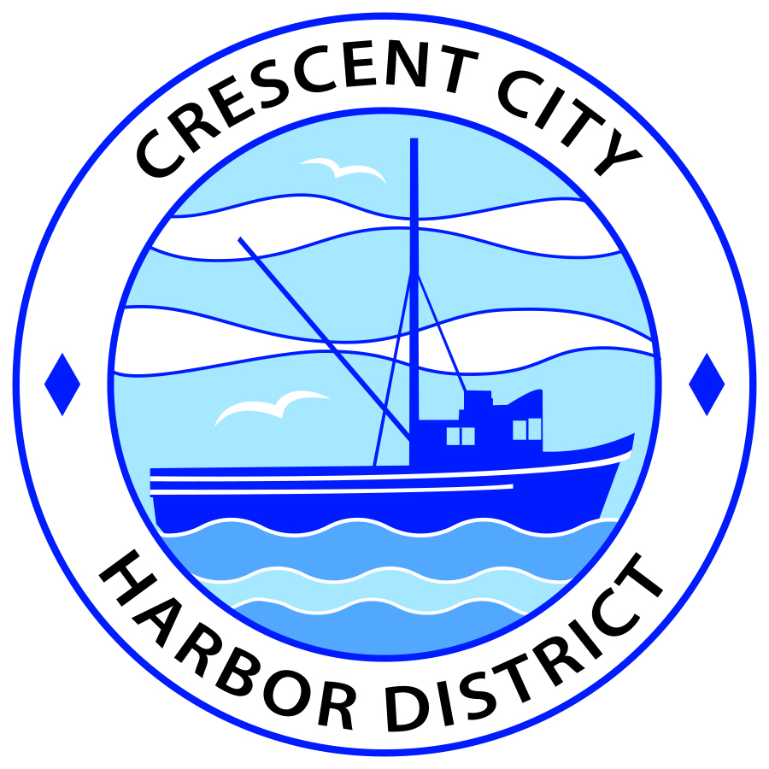
Board of Harbor Commissioners of the Crescent City Harbor District
Ronald A. Phillips, President Patrick A. Bailey, Secretary
James Ramsey, Commissioner Brian L. Stone, Commissioner Wes White, Commissioner

AGENDA
Board of Harbor Commissioners of the Crescent City Harbor District
At the Harbor District Office meeting room
101 Citizens Dock Road, Crescent City, California 95531

Special Meeting Tuesday, March 16, 2017 5:30 P.M.

The Board of Harbor Commissioners of the Crescent City Harbor District is now meeting in special session. Only those items that indicate a specific time will be heard at the assigned time. All other items may be taken out of sequence to accommodate the public and staff availability.

5:30 p.m. The Board of Harbor Commissioners will meet in open session to discuss the following agenda items.

Pledge of Allegiance

Public Comment

Public comments are welcomed and encouraged by the Board. The President invites anyone in the audience to speak to the Board of Harbor Commissioners to identify themselves and the matter they wish to discuss. The Harbor Commission will then determine if such matters should be discussed at this time or scheduled for a subsequent meeting. As per the District’s bylaws, each speaker shall be limited to a maximum of three (3) minutes.

- Analysis of Master Plan for Crescent City Harbor District RV Resort. Discuss Master Plan and direct staff accordingly

- Discussion concerning Master Plan Page 10 – tents, yurt, bike hostel, cabin, tiny house area. Discuss, approve revised plan, and direct staff accordingly

- Discussion concerning Master Plan Page 28 – recommended economic model for proposed Harbor site. Discuss, approve revisions, and direct staff as appropriate

- Discussion concerning Master Plan Page 9 – 14 back-in RV sites. Discuss, approve revisions, and direct staff as appropriate

- Discussion concerning Master Plan Page 11– 28 RV Sites, registration office and bath house.
Discuss, approve revisions, and direct staff as appropriate

- Discussion concerning Master Plan Page 8 – Tsunami Visitor Center, Pavilions.
Discuss, approve revisions, and direct staff as appropriate

- Discussion concerning Master Plan Page 42 – Marketing and Sales Milestones. Discuss, approve revisions, and direct staff as appropriate

- Discussion concerning Master Plan Pages 43; 44; 54 – Financial Analysis. Discuss, approve revisions, and direct staff as appropriate

- Selection of Operating Name for RV Resort. Discuss, select name, direct staff as appropriate

- Recap of Master Plan Revisions and set timeline for Project Development e.g. Engineering Drawings, Financing Search, etc. Discuss, set timelines, and direct staff as appropriate

- Adjournment
*** Adjournment until the next Board of Harbor Commissioners meeting scheduled for Tuesday, March 21, 2017 at 5:30 P.M. at the Harbor District Office, 101 Citizens Dock Road, Crescent City, California.

