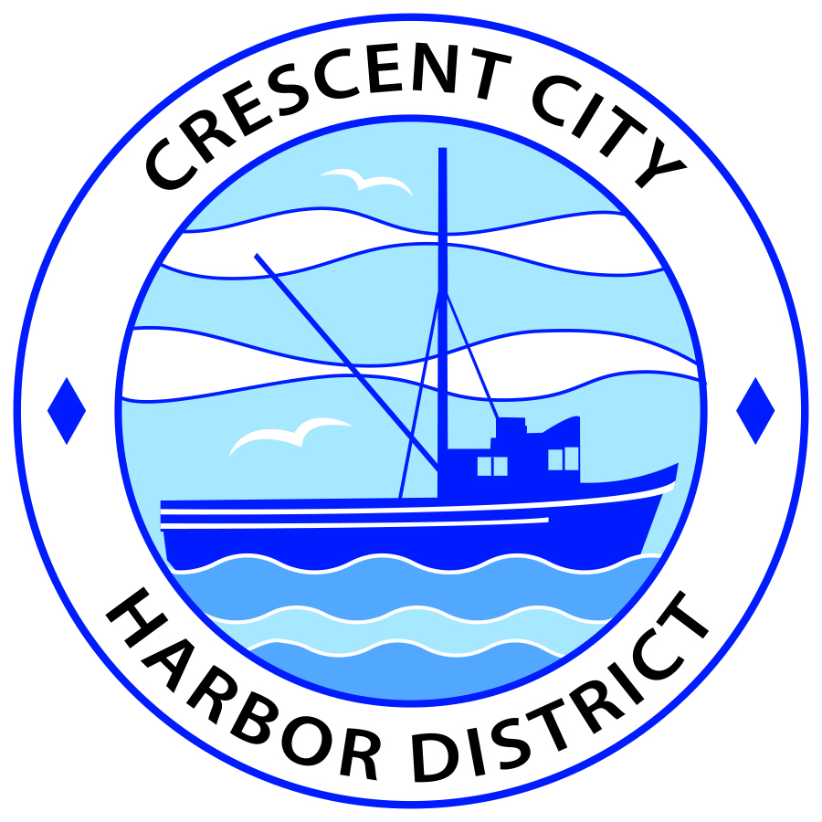
Regular Meeting
Board of Harbor Commissioners of the Crescent City Harbor District
Brian Stone, President Carol White, Secretary
James Ramsey, Commissioner; Rick Shepherd, Commissioner; Wes White, Commissioner

AGENDA

Date: Tuesday, 18 February, 2020

Time: Closed Session 1:45 p.m.
Open Session 2:45 p.m.

Place: Crescent City Harbor District Meeting Room

(Additional location joined via teleconference
in accordance with Government Code Section 54953)

Calle 58 #466A
53 y 55
Centro
Merida, Mexico

Harbor Commissioners may enforce, or for good cause extend, the three-minute time limit for each speaker.

Anyone requiring reasonable accommodation to participate in the meeting should contact the Harbor District at 707-464-6174 x 2 at least 48 hours prior to the meeting.

Call to Order

Roll Call

Pledge of Allegiance
Public Comment

This portion of the Agenda allows the public to comment to the Board on any issue not itemized on this Agenda. However, the Board may not take action or engage in discussion on any item that does not appear on the Agenda. Please limit comments to three minutes, and keep in mind that the public will have an opportunity to comment during the separate public comment period for every agenda item.
Adjourn to Closed Session
- CONFERENCE WITH LEGAL COUNSEL – EXISTING LITIGATION
Government Code Section 54956.9(d)(1)
Crescent City Harbor District v. Dutra et al.
Sacramento Superior Court Case No.: 34-2017-00215044-CU-BC-GDS

- CONFERENCE WITH LEGAL COUNSEL – EXISTING LITIGATION
Government Code Section 54956.9(d)(1)
Fansler v. Crescent City Harbor District
WCAB No.: ADJ12731825

- CONFERENCE WITH LEGAL COUNSEL – ANTICIPATED LITIGATION
Government Code Section 54956.9(d)(4): 1 case

Adjourn from Closed Session
Report out of Closed Session
Regular Session
- Consent Calendar

All items on this list are considered and acted on in one Motion. Anyone may request an item be removed from the Consent Agenda for separate consideration.
  - Approval of minutes of the February 4, 2020 Harbor Commission Meeting.

- New Business

  - Approve Harbor District Resolution Number 2020-001 Authorizing Investment of Monies in the Local Agency Investment Fund. Review and approve Resolution 2020-001 which adds current Board President and Board Secretary along with Immediate Past Board President and Immediate Past Board Secretary to the list of authorized signers on the Local Agency Investment Fund for the Crescent City Harbor District

  - Presentation by the Crescent Harbor Gallery on decoration of Harbor District decorative anchors, buoys and dolos. Art gallery representative will present design ideas for Harbor decorative fixtures. Review design ideas and grant permission to Harbor Art Gallery to place enhanced designs on Harbor District outdoor fixtures.

  - Consideration of lease proposal by Mr. Richard Bolen for the two bay garage located at 730 U.S. Hwy 101. Mr. Bolen would like to secure the two bay garage for working on his custom hot rods.

  - Consideration of a proposal by Mr. Richard Bolen for reaching an agreement with the Harbor District for occasional use of the facility at 201 Citizens Dock by the Northern Knights Car Club for meetings. Review, consider and advise staff accordingly.

  - Consideration of a proposal by Harbor Commissioner Ramsey to prepare the facility at 201 Citizens Dock Road for use as a community event center. After placing a new roof on the structure and installing ADA compliant bathrooms, Commissioner Ramsey is encouraging the Harbor District to repair or replace the furnace in the building and to refinish the floor so that the Harbor District can begin to realize some revenue from the facility by renting it out for community functions.

  - Appointment of Ad Hoc committees. President Stone will appoint members of Ad Hoc committees as needed for single issue topics to be considered in the near future.

  - Staffing Comparison Report. Presentation of staffing statistics comparing 2019 to 2020

- Unfinished Business

  - Solar PPA Update
  - Approve transfer of Wild Planet/Carvalho hoist lease to South Bend Products, L.L.C. Discuss and approve transfer.

- Communications and Reports

  - CEO Report.
  - Commissioner Reports.
Pursuant to the Brown Act, this item allows the Commissioners to briefly discuss activities engaged in since the previous public meeting.

- Adjournment
  - E
Adjournment to the Board of Harbor Commissioners next regular meeting scheduled for Tuesday, 17 March, 2020, at 2 P.M. at the Harbor District Office, 101 Citizens Dock Road, Crescent City, California.

