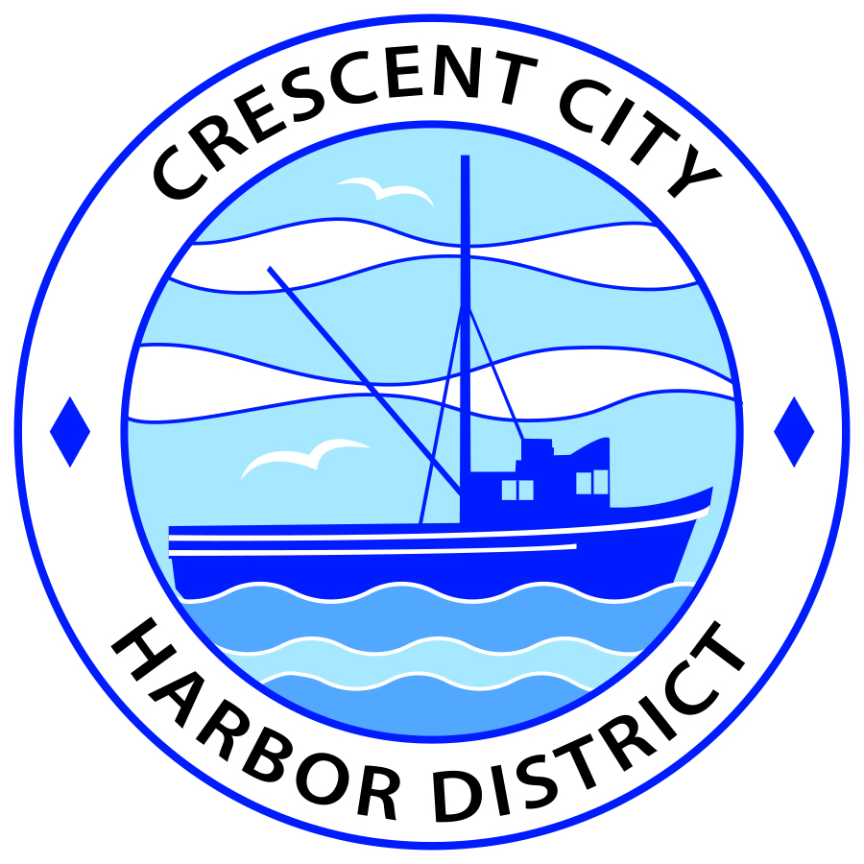
Board of Harbor Commissioners of the Crescent City Harbor District
Ronald A. Phillips, President Patrick A. Bailey, Secretary
James Ramsey, Commissioner Brian L. Stone, Commissioner Wes White, Commissioner

AGENDA
Board of Harbor Commissioners of the Crescent City Harbor District
At the Harbor District Office meeting room
101 Citizens Dock Road, Crescent City, California 95531

Regular Meeting Tuesday, February 7, 2017 4:30 P.M.

The Board of Harbor Commissioners of the Crescent City Harbor District is now meeting in regular session. Only those items that indicate a specific time will be heard at the assigned time. All other items may be taken out of sequence to accommodate the public and staff availability.

4:30 p.m. The Board of Harbor Commissioners will meet in open session to discuss the following agenda items.

Pledge of Allegiance

Public Comment

Public comments are welcomed and encouraged by the Board. The President invites anyone in the audience to speak to the Board of Harbor Commissioners to identify themselves and the matter they wish to discuss. The Harbor Commission will then determine if such matters should be discussed at this time or scheduled for a subsequent meeting. As per the District’s bylaws, each speaker shall be limited to a maximum of three (3) minutes.

Closed Session. The Board of Harbor Commissioners will now meet in closed session to discuss the following item:

(1)Pursuant to Government Code Section 54957 Performance evaluation of Crescent City Harbor District CEO

(2)PURSUANT TO GOVERNMENT CODE SECTION 54956.9 (d) (4) Pending Litigation: Crescent City Harbor District
Report out of Closed Session

- Consent Agenda
Requests to remove items from the Consent Agenda may be heard at this time
- Approval of the warrant list since the January 17, 2017 Harbor Commission Special Meeting
- Approval of the minutes of the January 17, 2017 Harbor Commission Regular Meeting
- Approval of the minutes for the January 24, 2017 Special Meeting of the Harbor Commission

- Update on Solar Power Project. Discuss the letter of intent and progress on the solar power project

- Discussion of petitioning Cal Trans to install a crosswalk at the intersection of Citizens Dock Road and U.S. Highway 101. Discussion of necessity for and the procedure for getting Cal Trans to place a crosswalk at the intersection

- Discussion and approval of lease terms for 730 Hwy 101 South. Discuss and approve as appropriate

- Discussion and approval of lease terms for 245 Anchor Way. Discuss and approve as appropriate

- Review of draft report from Bud Surles Consulting Group for harbor development. Discuss draft copy of report and collect comments for consultant.

- Discussion concerning naming of the RV facility at the corner of Anchor and Starfish Ways. Discuss potential names for the facility and select appropriate names so that staff can research availability of domain names

- Commissioner Reports. Reports from Commissioners who represent the Harbor District on the Chamber of Commerce, Tri-Agency, Inter Governmental Relations Committee, Harbor Safety Committee and any other civic or community groups and from any current ad hoc committees

- CEO Report. Report on current and planned items

- Board Comments. The Agenda allows Board of Harbor Commission members the opportunity to discuss items of general interest, provide a reference or other resource to staff and to ask for clarification or request staff to report to the Board on certain matters

- Adjournment
*** Adjournment to the Board of Harbor Commissioners meeting scheduled for Tuesday, February 21, 2017 at 5:30 P.M. at the Harbor District Office, 101 Citizens Dock Road, Crescent City, California.

