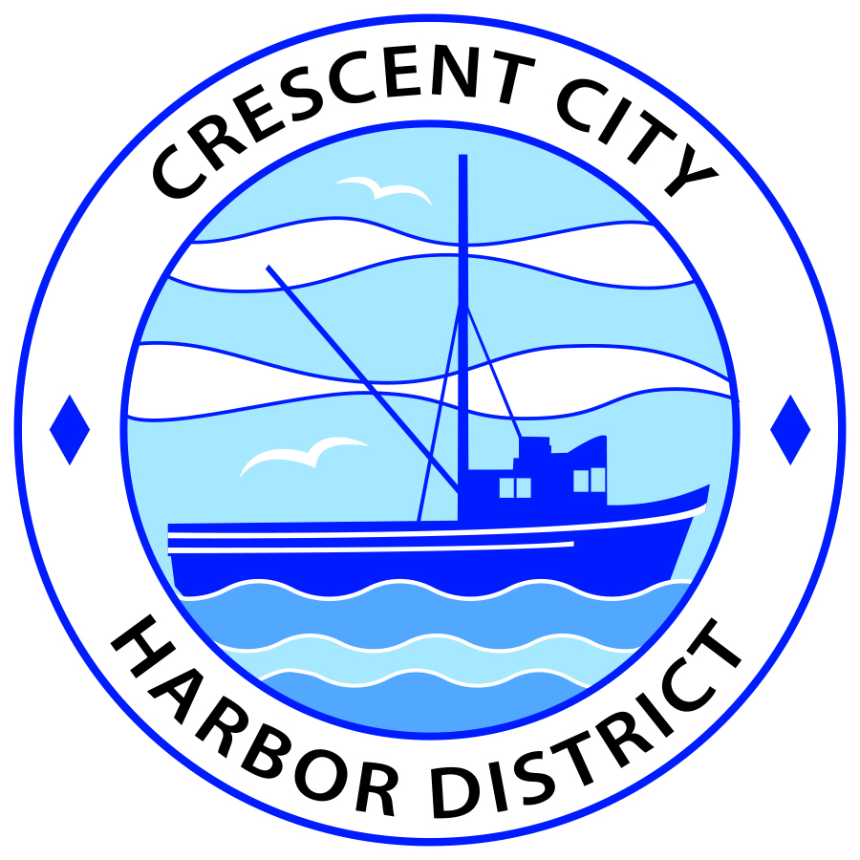
Regular Meeting
Board of Harbor Commissioners of the Crescent City Harbor District
James Ramsey, President Wes White, Secretary
Rick Shepherd, Commissioner Brian L. Stone, Commissioner, Carol White, Commissioner
AGENDA

Date: Tuesday, 6 August, 2019

Time: Closed Session 2:00 p.m.
Regular Session: 2:30 p.m.

Place: Crescent City Harbor District Meeting Room
101 Citizens Dock Road, Crescent City, CA 95531

Public participation in this meeting is encouraged and will be accommodated during the public comment period for each item on the agenda. The public will have an opportunity to speak on each item on the Agenda, but will be limited to a comment period of three minutes per item. The public comment period is not intended to be a question and answer session between members of the public and the Commission. The President of the Board of Harbor Commissioners or the Presiding Member of the Board of Harbor Commissioners may enforce, or for good cause extend, the three-minute time limit for each speaker.

Anyone requiring reasonable accommodation to participate in the meeting should contact the Harbor District at 707-464-6174 x 2 at least 48 hours prior to the meeting.

Call to Order

Roll Call

Pledge of Allegiance

Public Comment

This portion of the Agenda allows the public to comment to the Board on any issue not itemized on this Agenda. However, the Board may not take action or engage in discussion on any item that does not appear on the Agenda. Please limit comments to three minutes, and keep in mind that the public will have an opportunity to comment during the separate public comment period for every agenda item.
Closed Session
CONFERENCE WITH LEGAL COUNSEL – EXISTING LITIGATION
Pursuant to subdivision (1) of paragraph (d) of Government Code Section 54956.9:
- Crozier v. Crescent City Harbor District Del Norte Superior Court Case No.: CVPI-2018-1194

- CONFERENCE WITH REAL PROPERTY NEGOTIATORS
Government Code Section 54956.8
Property: APN 117-180-021-000
Agency Negotiator: Charlie Helms CEO/Harbor Master
Negotiating Parties: Summit Development Corporation
Under Negotiation: Price and Terms of Commercial Lease

Report out of Closed Session

Regular Session

- Consent Calendar

All items on this list are considered and acted on in one Motion. Anyone may request an item be removed from the Consent Agenda for separate consideration.
  - Approval of the minutes of the 2 July, 2019 Harbor Commission Meeting

  - Approval of the warrant list since the 16 July, 2019 Harbor Commission Meeting

  - Approval of the minutes of the 16 July, 2019 Harbor Commission Meeting

- New Business

  - Presentation from the North Coast Marine Mammal Center requesting permission to have their annual 5k and 10k Run for the Seals pass through the Harbor District. Review insurance documents and run plans, discuss and approve

  - Schedule a public workshop for Harbor Commissioners to discuss necessity for placement of additional signage at Harbor District. Discuss signage and messaging options and direct staff as needed

  - Progress update on Harbor tourist map. Review the draft, discuss any edits desired by Commissioners, and direct staff as appropriate

  - Presentation concerning animal signage designed by Friends of the Harbor District. Review staff proposal of signage location, discuss and approve

  - Approve request from Friends of the Harbor District for a haunted house. Proposal is to use the building formerly occupied by Englund Marine & Industrial Supply. Discuss and approve.

- Unfinished Business

  - Solar Project Update. Update on American Diversified Energy Solar Project.

- Communications and Reports

  - CEO Report.

  - Commissioner Reports.
Pursuant to the Brown Act, this item allows the Commissioners to briefly discuss activities engaged in since the previous public meeting.

- Adjournment
  - E
Adjournment to the Board of Harbor Commissioners next regular meeting scheduled for Tuesday, August 20, 2019 at 2:00 P.M. at the Harbor District Office, 101 Citizens Dock Road, Crescent City, California.

