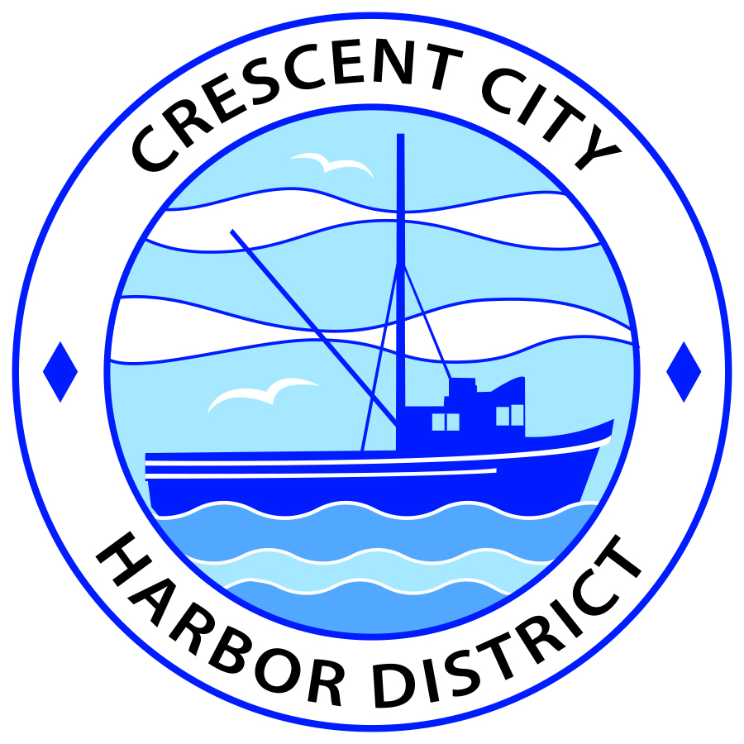
Board of Harbor Commissioners of the Crescent City Harbor District
Patrick A. Bailey, President James Ramsey, Secretary
Ronald A. Phillips, Commissioner Brian L. Stone, Commissioner Wes White, Commissioner

AGENDA
Board of Harbor Commissioners of the Crescent City Harbor District
At the Harbor District Office meeting room
101 Citizens Dock Road, Crescent City, California 95531

Special Meeting Thursday July 5, 2018 5:30 P.M.

The Board of Harbor Commissioners of the Crescent City Harbor District is now meeting in special session. Only those items that indicate a specific time will be heard at the assigned time. All other items may be taken out of sequence to accommodate the public and staff availability.

5:00 The Board of Harbor Commissioners will meet in open session to discuss the following agenda items.

Pledge of Allegiance

Public Comment

Public comments are welcomed and encouraged by the Board. The President invites anyone in the audience to speak to the Board of Harbor Commissioners to identify themselves and the matter they wish to discuss. The Harbor Commission will then determine if such matters should be discussed at this time or scheduled for a subsequent meeting. As per the District’s bylaws, each speaker shall be limited to a maximum of three (3) minutes.

- Presentation by Bill Cochran, Redwoods Leavitt Agency, on the annual renewals of the Harbor District’s Property, Marine, Vehicles and Public Officials Liability insurance policies. Discuss renewal options and approve

- Presentation by Lessee for leasehold lease extension of 140 Marine Way property. Discuss and direct staff to proceed accordingly

- Review design options for solar panel supporting car ports for the Harbor District. Review design options and select one appropriate option

- Review and approve budget for FY 2018 – 2019. Discuss, approve and direct staff accordingly

- Update on the progress of the Citizens Initiative addressing the Harbor Debt situation. Listen to presentation and discuss as needed

- Discussion of Harbor Debt situation, report on conversations regarding options for addressing debt challenges and options for Harbor fundraising including Citizens Initiative. Review, discuss strategy and direct staff if action is needed

- Board Comments. The Agenda allows Board of Harbor Commission members the opportunity to discuss items of general interest, provide a reference or other resource to staff and to ask for clarification or request staff to report to the Board on certain matters

- Adjournment
*** Adjournment to the Board of Harbor Commissioners meeting scheduled for Tuesday, July 17, 2018 at 5:30 P.M. at the Harbor District Office, 101 Citizens Dock Road, Crescent City, California.

