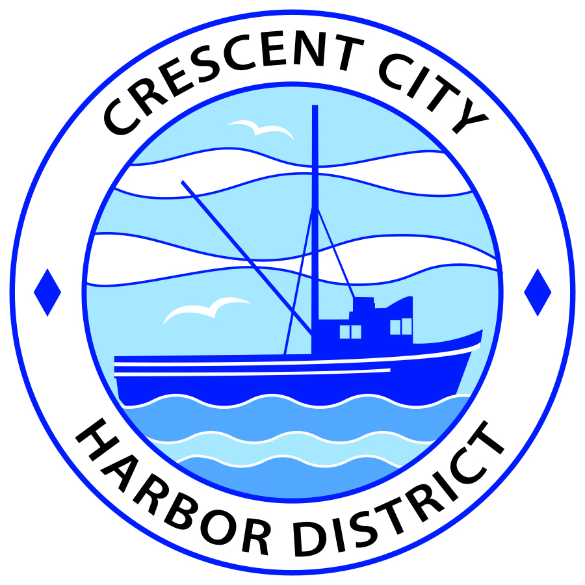
Board of Harbor Commissioners of the Crescent City Harbor District
Patrick A. Bailey, President James Ramsey, Secretary
Ronald A. Phillips, Commissioner Brian L. Stone, Commissioner Wes White, Commissioner
AGENDA
Board of Harbor Commissioners of the Crescent City Harbor District
At the Harbor District Office meeting room
101 Citizens Dock Road, Crescent City, California 95531

Special Meeting Wednesday, 16 May, 2018 1:00 P.M.
The Board of Harbor Commissioners of the Crescent City Harbor District is now meeting in Special Session.

1:00 p.m. The Board of Harbor Commissioners will meet in open session to participate in an orientation and training session

Pledge of Allegiance

Public Comment

Public comments are welcomed and encouraged by the Board. As per the District’s bylaws, each speaker shall be limited to a maximum of three (3) minutes.

- Agenda Item #1: Two-hour training session for Harbor Commissioners on ASUS Chromebooks that were purchased to improve communications and reduce paper usage.

- Adjournment.
*** Adjournment to the Board of Harbor Commissioners Regular Meeting scheduled for Tuesday, 19 June, 2018 at 5:30 P.M. at the Harbor District Office, 101 Citizens Dock Road, Crescent City, California.

