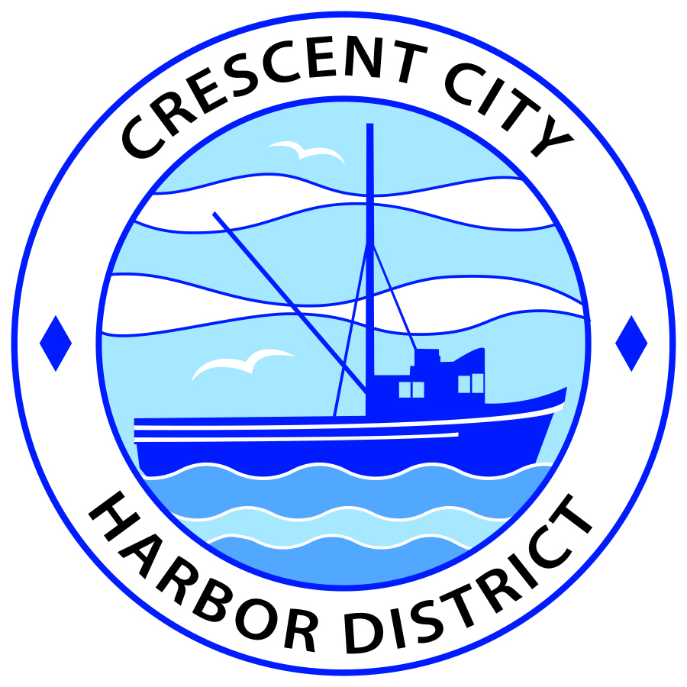
October 1, 2019

Crescent City Harbor District
REQUEST FOR PROPOSALS (RFP)
PROFESSIONAL SERVICES CONTRACT

FOR
AUDIT SERVICES

PROPOSALS DUE: October 25, 2019
Crescent City Harbor District
101 Citizens Dock Road
Crescent City, CA 95531

I. INTRODUCTION
The Crescent City Harbor District is seeking proposals from qualified firms to provide professional audit services. The District seeks the timely preparation and filing of required financial statements in accordance with generally accepted auditing standards.
II. BACKGROUND
Del Norte County is located along California’s beautiful North Coast surrounded by Redwood National and State Parks. Del Norte County is the most northwest county in California, bordered on the west by the Pacific Ocean, on the south by Humboldt County, on the east by Siskiyou County, and on the north by the Oregon border. Del Norte County enjoys a mild climate and natural beauty that make it a wonderful place to visit and to live.
The estimated population of Del Norte County is 28,610. Crescent City, the only incorporated city in the County and the County Seat, has an estimated population of 7,643. The County is located along the Highway 101 corridor approximately 350 miles in between Portland, Oregon to the north and San Francisco to the south. While beautiful, the community is also remote, with median household incomes below and unemployment well above the statewide averages.
The Crescent City Harbor District is a California Special District formed and operating under the Harbors and Navigation Code. The Harbor District owns and operates the local marina, which was recently rebuilt after tsunamis in 2006 and 2011 nearly destroyed it. The newly rebuilt, state of the art marina was designed to resist a 50-year tsunami.
III. SCOPE OF SERVICES
The Crescent City Harbor District is seeking audit services for the current year and is interested in retaining an auditor for up to five years. The audit must be conducted in accordance with generally accepted auditing standards established by the American Institute of Certified Public Accountants, and the General Accounting Office “Standards for Audit of Governmental Organizations, Programs, Activities and Functions.”
The audit must include the General Fund, preparation of the Financial Report for timely reporting to State Lands and other appropriate State of California agencies, as well as the Management's Discussion and Analysis statement.
IV. SELECTION CRITERIA
Evaluation of proposals will be based on the criteria listed in this RFP and submitted with the proposal. Proposals must include sufficient information for the selection team to evaluate and make a determination about the Contractor’s appropriateness for the position. Failure to submit all required information may be cause for rejection of the proposal.
Key components of the evaluation include the adequacy of the described scope of services, the Contractor’s experience and qualifications, the cost proposal, and the references. The following scale will be used in evaluating the above criteria:
- Cost 20 points
- Scope of services 25 points
- Experience and qualifications 30 points
- References 15 points
- Overall proposal 10 points
In using the above criteria and scoring system the Harbor District’s goal is to identify the proposal that best meets the Harbor District’s requirements and which guarantees the “best value” to the Harbor District and the community it serves.
The Harbor District reserves the right to reject any and/or all proposals. No guarantee is made that any contract will be awarded pursuant to this RFP. All costs incurred in the preparation of the proposals will be borne by Contractor.
The Harbor District is committed to providing minority and disadvantaged business enterprises the opportunity to submit proposals in response to this RFP. No proposal will be rejected on the basis of age, race, color, sex, gender, religion, creed, national origin, marital status, sexual orientation, political affiliation, or disability.
The contract award will be subject to and contingent upon verification of qualifications, licensing, bonding, insurance, and all other requirements under federal, state, and local law.
V. REQUIREMENTS OF PROPOSAL
All proposals must be submitted in the order set forth below to assist in the review process. Entire contents of proposal should not exceed 20 pages.
- Title Page. Identify the RFP, the Contractor’s information, and certification that the person submitting the proposal has authority to enter into a contract with the Harbor District if successful. The title page must bear the signature of the authorized person.
- Summary. A short summary describing experience, qualifications, and commitment to the work requested in this RFP. Ensure that the minimum required qualifications are included in this summary.
- Qualifications. A detailed description of qualifications including experience, education, licenses, insurance, and any other relevant information pertaining to Contractor’s ability to perform the services.
- Scope of Services. A description of the process and approach to be used in providing the services described in section III – Scope of Services.
- Cost Proposal. An estimate of the cost to perform the services, including hourly rate(s), overhead costs, reimbursable expenses, charges, etc.
- References. Professional letters of reference may be submitted with the proposal, but are not required. These should be from businesses or agencies for which Contractor has provided services.
- Additional Materials. Include additional materials as appendices if necessary and relevant to the proposal.

The Harbor District will not reimburse for any costs incurred in the preparation and submittal of proposals. The Harbor District may request clarification or additional information during the evaluation process. Modifications to proposals may be requested in writing prior to the submission deadline. Proposals may be withdrawn prior to the submission deadline if requested in writing. No modifications to of proposals will be allowed after the submittal deadline.
VI. PROPOSAL TIMELINE
All proposals are due on or before October 25, 2019 at 5:00 p.m. Proposals must be received at the Harbor District office, located at 101 Citizens Dock Way, Crescent City, California 95531 before the due date and time. Proposals not received before this time will not be considered.
A selection committee will review each proposal and, if necessary, conduct interviews with Contractors and key personnel, if any. The selection committee will make a tentative decision on or before October 31, 2019, and present their recommendation to the Harbor District’s Board of Commissioners at its regularly scheduled meeting on November 12, 2019.
The selection committee will work with the Harbor District’s attorney to negotiate a draft agreement with the top-ranking Contractor with a goal of completing the negotiation process by November 15, 2019. If an agreement cannot be reached with the top-ranking Contractor, the selection committee will be asked to make additional recommendations.
The Harbor District retains the right to withdraw this RFP at any time, without prior notice; to reject any or all proposals; and to waive any irregularities or informalities in a proposal or in the proposal process.
VII. SUBMITTAL DIRECTIONS
Please submit 5 hard copies of the proposal to the Harbor District office located at 101 Citizens Dock Way, Crescent City, California 95531 on or before the submission deadline. Proposals should be addressed to the Crescent City Harbor District, attention: Traci Fansler.
VIII. COMMUNICATIONS
To provide the same information to all Contractors, questions will not be answered individually. Any oral responses to questions are not binding on the Harbor District. The Harbor District will post all questions received, along with written responses, to the Harbor District website. It is the responsibility of all Contractors to check the website for questions and answers prior to submitting a proposal. The Harbor District will not respond to any questions submitted after October10, 2019. Any questions regarding this RFP must be directed to:
Traci Fansler
101 Citizens Dock Way
Crescent City, CA 95531
(707) 464-6174

