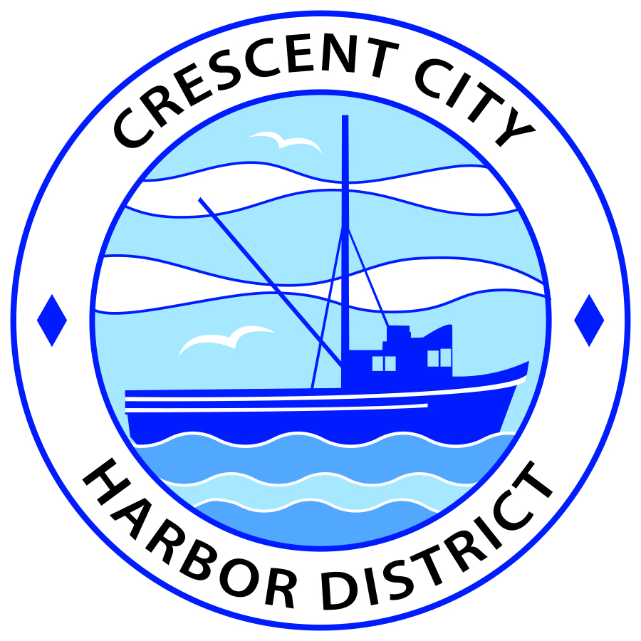
Board of Harbor Commissioners of the Crescent City Harbor District
Patrick A. Bailey, President James Ramsey, Secretary
Ronald A. Phillips, Commissioner Brian L. Stone, Commissioner Wes White, Commissioner
AGENDA
Board of Harbor Commissioners of the Crescent City Harbor District
At the Harbor District Office Meeting Room
101 Citizens Dock Road, Crescent City, California 95531

Regular Meeting Tuesday, May 15, 2018 5:30 P.M.

The Board of Harbor Commissioners of the Crescent City Harbor District is now meeting in regular session. Only those items that indicate a specific time will be heard at the assigned time. All other items may be taken out of sequence to accommodate the public and staff availability. Anyone requiring reasonable accommodation to participate in the meeting should contact the Harbor District at 707-464-6174 x 2 at least five (5) days prior to the meeting.

5:30 p.m. The Board of Harbor Commissioners will meet in open session to discuss the following agenda items.

Pledge of Allegiance

Public Comment

Public comments are welcomed and encouraged by the Board. The President invites anyone in the audience to speak to the Board of Harbor Commissioners to identify themselves and the matter they wish to discuss. The Harbor Commission will then determine if such matters should be scheduled for a subsequent meeting. As per the District’s bylaws, each speaker shall be limited to a maximum of three (3) minutes.

- Consent Agenda
Requests to remove items from the Consent Agenda may be heard at this time
- Approval of the warrant list since the May 1, 2018, Harbor Commission Meeting
- Approval of the minutes of the May 1, 2018 Harbor Commission Meeting

- Review and approve bids to repair and re-roof the two-bay garage building located at 730 Highway 101 South Review and approve

- Review and approve Resolution 2018-004 petitioning the Del Norte County Board of Supervisors to place the Citizens Initiative Measure on the November 2018 General Election ballot. Review, approve and sign.

- Discuss Harbormaster Helms joining Rikuzentakata delegation in June to inspect vertical evacuation structures, protective sea walls and harbor safety measures. Discuss and approve.

- Review and approve renewal of hoist leases for seafood buyers. Review lease terms, discuss and approve.

- Review design options for solar panel supporting car ports for the Harbor District. Review design options and select one appropriate option

- Review and discuss Strategic Planning Facilitation Proposal from Rural Approaches. Review, discuss and direct staff accordingly

- Update on the progress of the Citizens Initiative addressing the Harbor Debt situation. Listen to presentation and discuss as needed

- Update on options for addressing the Harbor District debt situation. Listen to presentation and discuss as needed

- CEO Report

- Commissioner Reports. Reports from Commissioners who represent the Harbor District on the Chamber of Commerce, Tri-Agency, Inter Governmental Relations Committee, Harbor Safety Committee and any other civic or community groups and from any current ad hoc committees.

- Board Comments. The Agenda allows Board of Harbor Commission members the opportunity to discuss items of general interest, provide a reference or other resource to staff and to ask for clarification or request staff to report to the Board on certain matters.

- Adjournment
*** Adjournment to the Board of Harbor Commissioners meeting scheduled for Tuesday June 19, 2018 at 5:30 P.M. at the Harbor District Office, 101 Citizens Dock Road, Crescent City, California.

Anyone requiring reasonable accommodation to participate in the meeting should contact the Crescent City Harbor District at 707-464-6174 x 2 at least five (5) days prior to the meeting.

