Regular Meeting Minutes of the
Board of Harbor Commissioners of the Crescent City Harbor District
Harbor District Office, 101 Citizens Dock Road  Crescent City, CA 95531 | December 20, 2016  5:30 p.m.
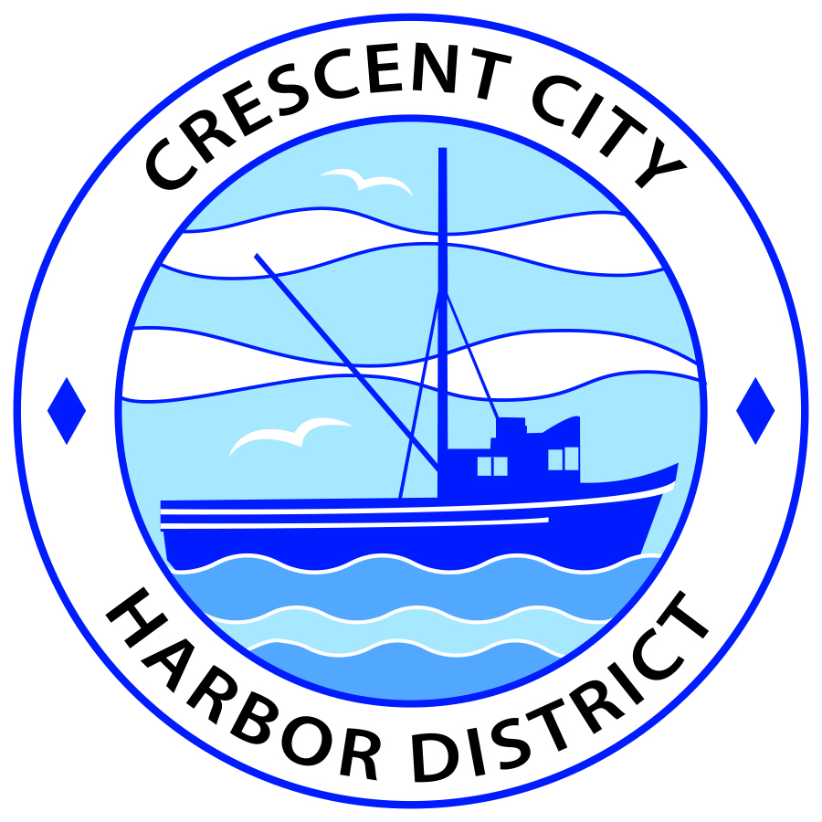

Call to Order
President Ramsey called the meeting to order in open session at 5:30 p.m.

Roll Call
Present were Commissioner White, Commissioner Bailey, Commissioner Phillips, Secretary Feller, and President Ramsey. Also present were Harbormaster Helms and Counsel Black.

Pledge of Allegiance
The Pledge of Allegiance was led by Secretary Feller.

Public Comment on Closed Session Items
President Ramsey asked for public comment on closed session items and received none.

The Board of Harbor Commissioners adjourned to closed session at 5:32 p.m.

Closed Session Items

- PURSUANT TO GOVERNMENT CODE SECTION 54956.9 (d) (4)
Anticipated Litigation: Crescent City Harbor District

The Board of Harbor Commissioners reconvened in open session at 6:00 p.m.
Report Out of Closed Session
Counsel Black reported that an action was taken in closed session.
Action: On a motion by Commissioner Phillips, seconded by Secretary Feller, and carried unanimously, the Board of Harbor Commissioners of the Crescent City Harbor District approved pursuit of a warranty-related lawsuit pertaining to conditions of reconstruction of the inner boat basin, specifically electrical and plumbing issues, against The Dutra Group, Inc., a California Corporation; Dutra Construction, a California Corporation; G.B. Reese Electric, Inc., an Oregon Corporation; Eaton Corporation, an Ohio corporation; Ward Stover, individually and d.b.a. Stover Engineering, DataCommSys, a business organization, from unknown, Kennedy/Jenks Consulting, a California Corporation, and DOES 1 through 20, inclusive; Bellingham Marine, Ben C. Gerwick Engineers; and Maples Plumbing.

Public Comment
President Ramsey asked for public comment and received none.

Business Items

- Consent Agenda

- Approval of the warrant list since the December 6, 2016 Harbor Commission Regular Meeting
- Approval of the minutes of the December 6, 2016 Harbor Commission Regular Meeting

Commissioner Phillips made a motion to approve and Secretary Feller seconded.
Commissioner White requested clarification on several warrants. He questioned the reason that multiple checks were being issued to the same account (Harbormaster Helms replied that he believed it was due to itemization but would check) and if the Harbor would be reimbursed for the check to Steelhead; it will not. Commissioner Phillips asked if the purchased PVC was for the dock and Helms explained that it is to replace conduit under Citizen’s Dock. Commissioner White asked about a payment to the SWRCB and Helms offered that it was for the annual dredging permit. He also asked if a meeting had been held for Friends of the Harbor as noted in the minutes and Secretary Feller stated that one had not.
Action: On a motion by Commissioner Phillips, seconded by Secretary Feller, and carried on a 5-0 polled vote the Board of Harbor Commissioners of the Crescent City Harbor District approved the warrant list as submitted; and with a 4-0 polled vote, with Commissioner Phillips abstaining, the Board of Harbor Commissioners of the Crescent City Harbor District approved the minutes as submitted.

- Review preliminary design plans submitted by Harbor Consultant

Harbormaster Helms offered that the design plans had been delivered on Saturday and that a 90-day process to review would follow to include the receipt of commentary from the Commissioners, design rework, resubmittal, and so on. It was clarified that the consultant had considered the entire Harbor in his plans. The Commissioners requested that staff look into whether the proposed shelter structures within the green belt were allowable. The Commissioners also raised questions about the locating of shops behind Englund Marine, ownership and maintenance of tiny homes, and pull-through options for RV’s. It was opined that areas in the center of C, D, and E would provide 17-18 pull-through sites if the service road near the hotel was added, and that the two strips near Alber’s provide good placement for yurts and tents. Helms noted that the Coastal Commission wants to see a range of options available with affordable lodging. Secretary Feller suggested the addition of 1 or 2 ADA access points to the beach to further the Coastal Commission desire to provide access.
Commissioner White questioned what directions the consultant was provided and Helms responded that it was to provide plans to create the greatest revenue for the Harbor.
Additional commentary included that good information was provided within the plans on prices and SAM park ratings, that consideration should be given to tearing down unused buildings, and that simple bathroom and shower options should be reviewed. It was noted that the lease on Bayside was up on or around 2022 and could be considered for further development. Lastly, the pros and cons of nearby park model resorts were reviewed.
Harbormaster Helms stated that he would send out a list of questions and concerns he had heard to the Commissioners for review and provide that list and any additional comments to the consultant.
- Update on solar power project

No update provided.

- Discussion concerning updating Harbor District service rates and fees

Harbormaster Helms requested that the Commissioners provide him with any additional commentary on the proposed rate and fee schedule. Commissioner Phillips asked about a key card charge which had been added and Helms noted that it was in anticipation of using key cards for the bathroom, laundry, and shower facilities; such a card can be turned off, on, and tracked. Commissioner White questioned why multiple rates were listed in some areas and Helms replied that it was to provide options to the Board when voting on the topic.

Discussion took place regarding Ms. Lewis’ public comment that reducing fees can have a negative effect and it was agreed that her comments were insightful but that small sport boats do not fall into the same category and could be considered for fee reduction. Harbormaster Helms did note that he had added a semi-annual fee for seasonal rentals. The Commissioners briefly reviewed sailboats and the differing taxes they are charged between states.

A brief review of dry storage included possible locations, the effort by Harbormaster Helms to obtain fence pricing, and the method and difficulty of wrapping boats. The Board was in agreement that staff should reach out to possible customers in an effort to see if this would be a service that they would use.

Commissioner White questioned the personnel costs listed on page six and Helms said it was based on Brookings’ rate but would give it further review. Secretary Feller questioned if shower use was intended for tenants only and what would happen if the County provided a token program for the homeless. Harbormaster Helms provided insight to his past experience with such programs and advised the Board against it. Some discussion ensued about offering a repair boat rate and attracting mobile or stationary repair tenants to provide this service.

Harbormaster Helms stated that the Commissioners should email any last thoughts and that staff would put together a final proposed fee schedule for January to begin the process of adoption.

- Commissioner Reports

Commissioner White noted that the Annual Chamber dinner would take place on Saturday, January 28 at the Tolowa Event Center at 5 p.m. No other meetings were held. President Ramsey requested that a budget meeting and a Friends of the Harbor meeting be held in January.

- CEO Report

Commissioner Phillips questioned why some lines had a negative balance on the aging summary report and Harbormaster Helms replied that it was because those customers pay in advance. Phillips also inquired about the overdue amount for Alber’s and Helms stated that it was not for rent but he was unsure of what it was regarding. Other outstanding receivables that Helms stated he would review with Finance Director Fansler were Global Hoist, South Beach Outfitters (which Helms stated should be closed out), and an additional 12 accounts who were still charging and owed over 90 days.
Secretary Feller inquired about the boat that the Harbor filed suit against and Helms noted that there were making small payments but the Harbor was still pursuing a court action.
The Board requested that the trial balance sheet be removed and that an income statement, profit and loss statement, and balance sheet be provided monthly.
Commissioner White asked if the letter had been sent to State Lands Commission as requested by Secretary Feller regarding South Beach and Feller offered that the old lease should be reviewed first.
The Commissioners discussed and requested that the itemization of Home Depot charges be provided in a different manner.
The Commission offered Mr. Scott Feller a proclamation for his service, photos were taken by staff, and President Ramsey read the proclamation aloud.
- Board Comments

President Ramsey noted that he would be gone from February 27th through March 14th.
Secretary Feller thanked the Commissioners and staff for their hard work and recalled how much effort had been put into rebuilding the Harbor and the Harbor’s finances. He welcomed Mr. Stone and offered that he will also go through growing pains as they all did. Mr. Feller stated that he would appreciate if the Board pursued installation of a boardwalk down South Beach to the old restaurant, that it would give people something to do and that access through the rocks would increase safety. He stated this will be especially important if a resort is built.
Commissioner White offered that he will miss Mr. Feller and the he added an element that will be missed. He noted that Mr. Feller could be counted on to catch details that others would miss, and that he was talented at summarizing the thoughts of the Board. White welcomed Mr. Stone aboard.
Commissioner Bailey noted that he agreed with Mr. White’s sentiments, that there were no significant disagreements between he and Feller, that they achieved good things together, and that Feller’s time with the Senator had been a plus.
Commissioner Phillips recalled when he had three new Commissioners to work with plus one who did not seem to care to be present, that it was hell for two years and that he remembers an entire month where his time was spent trying to keep former Harbormaster Young from quitting. He noted that in the long run the group learned to work together and that he feels that it has been one of the best governmental bodies in the County. The Board always works through their differences to do what is best for the Harbor and he appreciates everything that Mr. Feller has done. He will miss him on the Board and invites him not to be a stranger.
President Ramsey relayed that they have had many interesting times working with tenants and ex-tenants, that he enjoyed Mr. Feller’s “drive throughs” and will miss him and his succinct way of saying things. He noted that it has been a pleasure and an honor to serve with him and he will be sorry to see him go.
Commissioner Feller again noted his appreciation for his fellow Commissioners and the staff.
- Adjournment

The Board of Harbor Commissioners adjourned at 7:20 p.m. to the next scheduled meeting on Tuesday, January 3, 2017 at 5:30 P.M. at the Harbor District Office, 101 Citizens Dock Road, Crescent City, California.

Attest:

______________________________
Kymmie Scott, Secretary to the Board

_______________________________
James Ramsey, President

_______________________________
Scott Feller, Secretary

