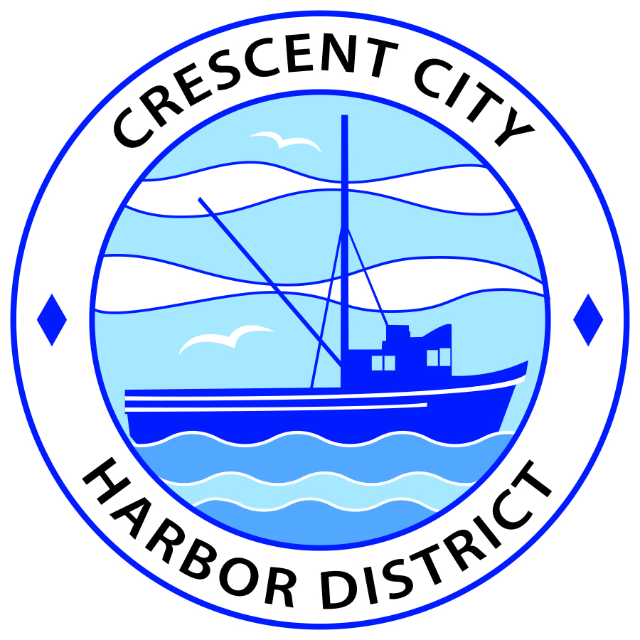
Special Meeting
Board of Harbor Commissioners of the Crescent City Harbor District
James Ramsey, President Wes White, Secretary
Rick Shepherd, Commissioner Brian L. Stone, Commissioner, Carol White, Commissioner
SPECIAL AGENDA

Date: Tuesday, May 14, 2019

Time: Closed Session: 3:00 p.m.

Place: Crescent City Harbor District Meeting Room
101 Citizens Dock Road, Crescent City, CA 95531

Public participation in this meeting is encouraged and will be accommodated during the public comment period for each item on the agenda. The public will have an opportunity to speak on each item on the Agenda, but will be limited to a comment period of three minutes per item. The public comment period is not intended to be a question and answer session between members of the public and the Commission. The President of the Board of Harbor Commissioners or the Presiding Member of the Board of Harbor Commissioners may enforce, or for good cause extend, the three-minute time limit for each speaker.

Anyone requiring reasonable accommodation to participate in the meeting should contact the Harbor District at 707-464-6174 x 2 at least 48 hours prior to the meeting.

Call to Order

Roll Call

Pledge of Allegiance

Public Comment

This portion of the Agenda allows the public to comment to the Board on any issue not itemized on this Agenda. However, the Board may not take action or engage in discussion on any item that does not appear on the Agenda. Please limit comments to three minutes, and keep in mind that the public will have an opportunity to comment during the separate public comment period for every agenda item.
Closed Session
CONFERENCE WITH REAL PROPERTY NEGOTIATORS
Pursuant to Government Code Section 54956.8:
- Property: 750 Highway 101 South, Bayside RV Park
Agency Negotiator; Charlie Helms, Harbor Master
Negotiating parties: Bruce Dwelly
Under Negotiation: Lease Price and Terms

Pursuant to Government Code Section 54956.8:
- Property: 700 U. S. Highway 101 South, Fishermen’s Restaurant Parking Lease
Agency Negotiator: Charlie Helms, Harbor Master
Negotiating Parties: Troy & Janey Grant
Under Negotiation: Lease Price and terms

Pursuant to Government Code Section 54956.8
- Property: 110 Anchor Way, North Coast Ocean Sports and Grill
Agency Negotiator: Charlie Helms, Harbor Master
Negotiating Parties: Scott Hillier
Under Negotiation: Lease Price and terms
Report Out of Closed Session

- Adjournment
  - E
Adjournment to the Board of Harbor Commissioners next regular meeting scheduled for Tuesday, May 21, 2019 at 2:00 P.M. at the Harbor District Office, 101 Citizens Dock Road, Crescent City, California.

