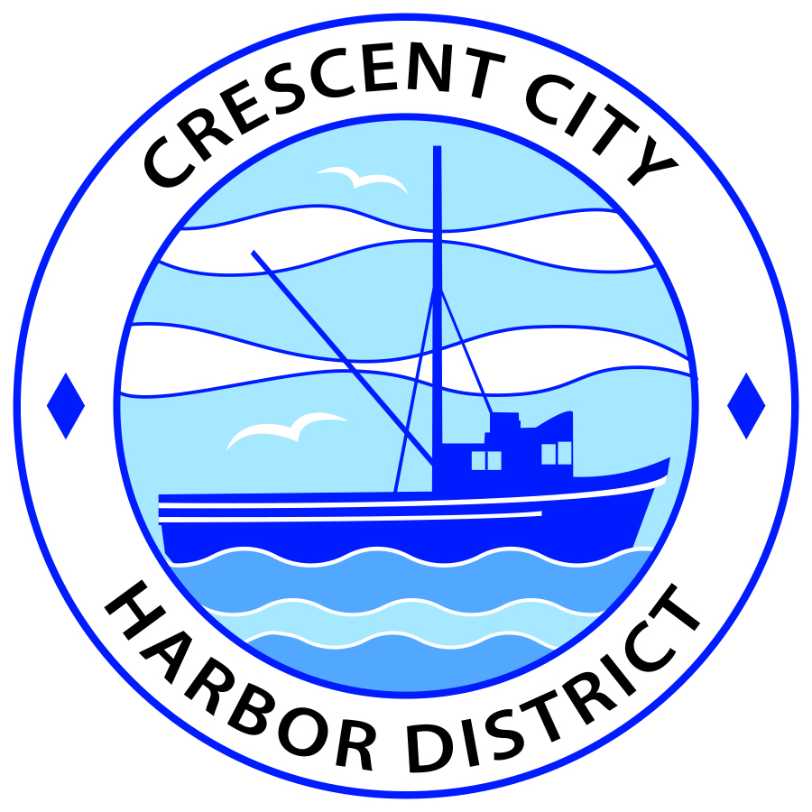
Regular Meeting
Board of Harbor Commissioners of the Crescent City Harbor District
James Ramsey, President Wes White, Secretary
Rick Shepherd, Commissioner Brian L. Stone, Commissioner Carol White, Commissioner

AGENDA

Date: Tuesday, 05 November, 2019

Time: 2:00 p.m. – CLOSED SESSION
2:30 p.m. – OPEN SESSION

Place: Crescent City Harbor District Meeting Room
101 Citizens Dock Road, Crescent City, CA 95531

Public participation in this meeting is encouraged and will be accommodated during the public comment period for each item on the agenda. The public will have an opportunity to speak on each item on the Agenda, but will be limited to a comment period of three minutes per item. The public comment period is not intended to be a question and answer session between members of the public and the Commission. The President of the Board of Harbor Commissioners or the Presiding Member of the Board of Harbor Commissioners may enforce, or for good cause extend, the three-minute time limit for each speaker.

Anyone requiring reasonable accommodation to participate in the meeting should contact the Harbor District at 707-464-6174, at least 48 hours prior to the meeting.

All meeting agendas, documents, and other writings (except for privileged documents) that are distributed to a majority of the Commissioners may be inspected by the public at the address listed above. A fee or deposit may be charged for a copy of these public records.

Call to Order

Roll Call

Pledge of Allegiance

Public Comment

This portion of the Agenda allows the public to comment to the Board on any issue not itemized on this Agenda. However, the Board may not take action or engage in discussion on any item that does not appear on the Agenda. Please limit comments to three minutes, and keep in mind that the public will have an opportunity to comment during the separate public comment period for every agenda item.

MOVE TO CLOSED SESSION

CONFERENCE WITH LEGAL COUNSEL
Pursuant to paragraph (4) of subdivision (d) of Government Code Section 54956.9, based on existing facts and circumstances, the legislative body of the local agency is deciding whether to initiate litigation (1 potential case).

RECONVENE OPEN SESSION
(2:30 p.m.)

Report from closed session.

- Consent Calendar

All items on this list are considered and acted on in one Motion. Anyone may request an item be removed from the Consent Agenda for separate consideration.
  - Approval of the Warrant List since the 15 October, 2019 Harbor Commission Meeting
  - Approval of the Minutes of the 15 October, 2019 Harbor Commission Meeting

  - Approval of the Minutes of the 23 October, 2019 Harbor Commission Special Meeting

- New Business

  - Consideration of funding for strategic community initiative. Cindy Vosburg, Executive Director, Chamber of Commerce, will present a strategic initiative for discussion and approval.
  - Consider the issuance of a “Notice of Default” to A.D.E. Discuss and approve.
  - Consider the evaluation criteria and set a date for the performance evaluation of the CEO / Harbor Master. Review proposed evaluation form. Discuss and approve.
  - Discuss use of old Englund Marine building for Holiday Bazaar and dates.
  - Review updated Titles and Job Descriptions for Office Staff. Discuss, edit, and approve.
  - Award audit contract to successful bidder. Review proposal and staff analysis and award contract to Harshwal and Company LLP Certified Public Accountants.

- Unfinished Business

- Harbor Facilities Plan. Review the final Harbor Facilities Plan and approve posting for a 30-day public comment period. Review, discuss, and approve.

- Review progress on updated tourist map. Staff will report on revisions made in response to direction from Commissioners.

- Communications and Reports

  - CEO Report.

  - Commissioner Reports.
Pursuant to the Brown Act, this item allows the Commissioners to briefly discuss activities engaged in since the previous public meeting.

- Adjournment
  - E
Adjournment to the Board of Harbor Commissioners next regular meeting scheduled for Tuesday, November 19, 2019 at 2:00 P.M. at the Harbor District Office, 101 Citizens Dock Road, Crescent City, California.

