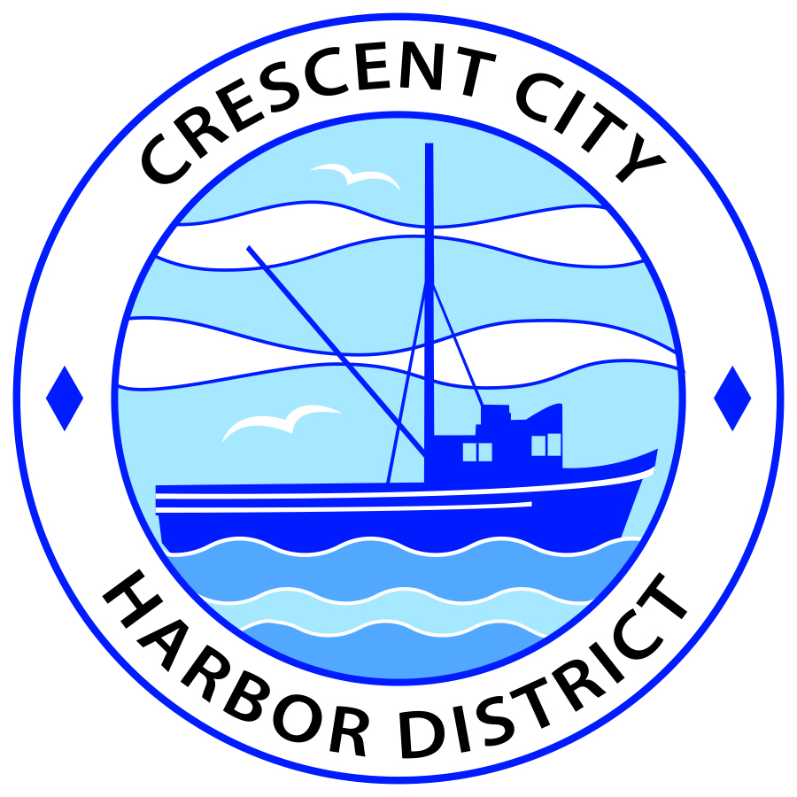
Board of Harbor Commissioners of the Crescent City Harbor District
Patrick A. Bailey, President James Ramsey, Secretary
Ronald A. Phillips, Commissioner Brian L. Stone, Commissioner Wes White, Commissioner

REVISED AGENDA
Board of Harbor Commissioners of the Crescent City Harbor District
At the Harbor District Office meeting room
101 Citizens Dock Road, Crescent City, California 95531

Special Meeting Monday September 10, 2018 12 P.M

The Board of Harbor Commissioners of the Crescent City Harbor District is now meeting in special session. Only those items that indicate a specific time will be heard at the assigned time. All other items may be taken out of sequence to accommodate the public and staff availability.

1:00 The Board of Harbor Commissioners will meet in open session to discuss the following agenda items.

Pledge of Allegiance

Public Comment

Public comments are welcomed and encouraged by the Board. The President invites anyone in the audience to speak to the Board of Harbor Commissioners to identify themselves and the matter they wish to discuss. The Harbor Commission will then determine if such matters should be discussed at this time or scheduled for a subsequent meeting. As per the District’s bylaws, each speaker shall be limited to a maximum of three (3) minutes.

Strategic Plan Board Workshop

- Review Draft Goals

Adjournment*** Adjournment to the Board of Harbor Commissioners meeting scheduled for Tuesday, September 18 2018 at 5:30 P.M. at the Harbor District Office, 101 Citizens Dock Road, Crescent City, California.

