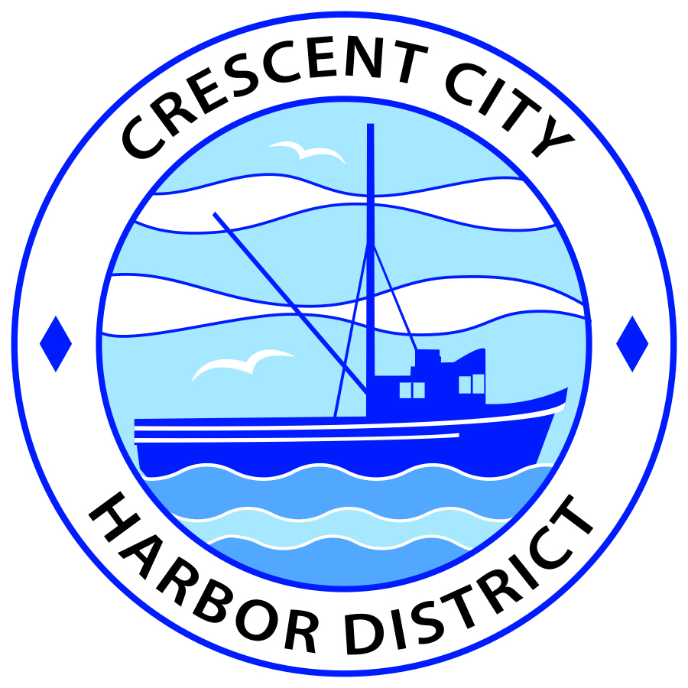
Board of Harbor Commissioners of the Crescent City Harbor District
James Ramsey, President Scott R. J. Feller, Secretary
Patrick A. Bailey, Commissioner Ronald A. Phillips, Commissioner Wes White, Commissioner

AGENDA
Board of Harbor Commissioners of the Crescent City Harbor District
At the Harbor District Office meeting room
101 Citizens Dock Road, Crescent City, California 95531

Regular Meeting Tuesday, September 20, 2016 5:30 P.M.

The Board of Harbor Commissioners of the Crescent City Harbor District is now meeting in regular session. Only those items that indicate a specific time will be heard at the assigned time. All other items may be taken out of sequence to accommodate the public and staff availability.

5:30 p.m. The Board of Harbor Commissioners will meet in open session to discuss the following agenda items.

Pledge of Allegiance

Public Comment prior to closed session.

Adjourn to Closed Session. The Board of Harbor Commissioners will now meet in closed session to discuss the following items:

- CONFERENCE WITH REAL PROPERTY NEGOTIATIORS: Pursuant to Government Code Section 54956.8 Property 128 Anchor Way, Crescent City, Agency Negotiator: Charles Helms

Report Out of Closed Session
5:45 p.m. The Board of Harbor Commissioners will meet in open session to discuss the following agenda items
Public Comment

Public comments are welcomed and encouraged by the Board. The President invites anyone in the audience to speak to the Board of Harbor Commissioners to identify themselves and the matter they wish to discuss. The Harbor Commission will then determine if such matters should be discussed at this time or scheduled for a subsequent meeting. As per the District’s bylaws, each speaker shall be limited to a maximum of three (3) minutes.

- Consent Agenda
Requests to remove items from the Consent Agenda may be heard at this time
- Approval of the warrant list since the September 6, 2016 Harbor Commission Special Meeting
- Approval of the minutes of the September 6, 2016 Harbor Commission Regular Meeting

- Presentation by Mr. Bill Cozzi concerning Harbor Beautification efforts. Hear presentation by Mr. Cozzi concerning his prior efforts and potential future plans. Direct staff accordingly.

- Update for the Harbor Commissioners on the status of the solar power project. Hear presentation, review information and direct staff accordingly

- Discussion concerning investigating, selecting and contracting an RV Park consultant to develop conceptual plans for the Harbor RV Anchorage site and adjoining proposed tourist serving accommodations. Review information and direct staff to take appropriate action.

- Presentation of response to bid for placement of fender piles on Citizens Dock. Discuss and direct staff to take action as necessary and appropriate

- Presentation of results from the Request for Proposal for Electrical Maintenance Services for the Crescent City Harbor District. Review and direct staff to take appropriate action

- Presentation of lease for 190 Citizens Dock Road. Review and approve document

- Presentation of Crescent City Harbor District Analysis of Financial Situation report. Discuss and direct staff to take appropriate action.

- Commissioner Reports. Reports from Commissioners who represent the Harbor District on the Chamber of Commerce, Tri-Agency, Inter Governmental Relations Committee, Harbor Safety Committee and any other civic or community groups and from any current ad hoc committees

- CEO Report. Report on current and planned items

- Board Comments. The Agenda allows Board of Harbor Commission members the opportunity to discuss items of general interest, provide a reference or other resource to staff and to ask for clarification or request staff to report to the Board on certain matters

- Adjournment
*** Adjournment to the Board of Harbor Commissioners meeting scheduled for Tuesday, October 4, 2016 at 5:30 P.M. at the Harbor District Office, 101 Citizens Dock Road, Crescent City, California.

