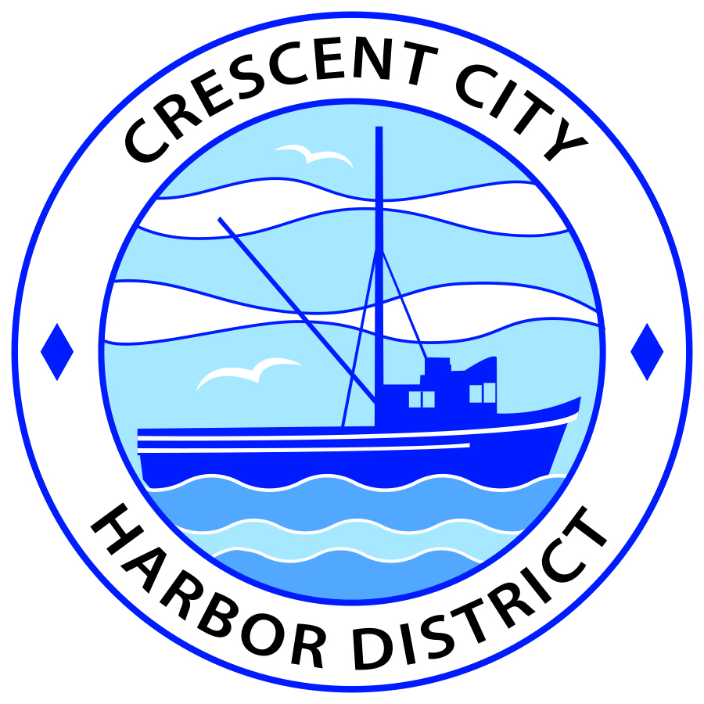
Board of Harbor Commissioners of the Crescent City Harbor District
Patrick A. Bailey, President James Ramsey, Secretary
Ronald A. Phillips, Commissioner Brian L. Stone, Commissioner Wes White, Commissioner
AGENDA
Board of Harbor Commissioners of the Crescent City Harbor District
At the Harbor District Office Meeting Room
101 Citizens Dock Road, Crescent City, California 95531

Regular Meeting Tuesday, 4 September, 2018 5:30 P.M.

The Board of Harbor Commissioners of the Crescent City Harbor District is now meeting in regular session. Only those items that indicate a specific time will be heard at the assigned time. All other items may be taken out of sequence to accommodate the public and staff availability. Anyone requiring reasonable accommodation to participate in the meeting should contact the Harbor District at 707-464-6174 x 2 at least five (5) days prior to the meeting.

5:30 p.m. The Board of Harbor Commissioners will meet in open session to discuss the following agenda items.

Pledge of Allegiance

Public Comment

Public comments are welcomed and encouraged by the Board. The President invites anyone in the audience to speak to the Board of Harbor Commissioners to identify themselves and the matter they wish to discuss. The Harbor Commission will then determine if such matters should be scheduled for a subsequent meeting. As per the District’s bylaws, each speaker shall be limited to a maximum of three (3) minutes.

- Consent Agenda
Requests to remove items from the Consent Agenda may be heard at this time
- Approval of the warrant list since the 21 August, 2018, Harbor Commission Meeting
- Approval of the minutes of the 21 August, 2018 Harbor Commission Meeting

- Authorize use of the Harbor District Meeting Room as the Precinct #17 polling place for the November 6, 2018 General Election
If approved, cancel or re-schedule the Commission meeting that is scheduled for that date

- Presentation by Pat Rideout on proposed improvements at The Chart Room. Mr. Rideout will share plans for upgrades he desires to make at The Chart Room

- Discuss placement of Floating Christmas tree at the Outer Boat Basin for Holiday Season. Ken Cowan, North Coast Ocean Sports and Grill, will present his idea and a plan for holiday decoration at the Harbor District. Discuss and direct staff accordingly

- Discussion about researching the possibility of hosting the Visitors Bureau Information center at 201 Citizens Dock Road. Discussion about mechanics of preparing the old Englund Marine building in advance of extending an invitation to the Visitors Bureau to operate a facility at the Harbor District

- Update on the progress of seeking funding for the Vertical Evacuation Center at the Crescent City Harbor District. Staff report on progress of locating funding opportunities for Vertical Evacuation Center

- Update on the progress of the solar energy project. Deputy Harbor Master Lane Tavasci will update the Board of Harbor Commissioners on the solar project

- Update on the progress of the Citizens Initiative addressing the Harbor District debt situation. Listen to presentation and Discuss

- Discussion of Harbor District debt situation and options for fundraising to meet debt challenge. Review, discuss strategy and direct staff if action is needed

- CEO Report

- Commissioner Reports. Reports from Commissioners who represent the Harbor District on the Chamber of Commerce, Tri-Agency, Inter Governmental Relations Committee, Harbor Safety Committee and any other civic or community groups and from any current ad hoc committees.

- Board Comments. The Agenda allows Board of Harbor Commission members the opportunity to discuss items of general interest, provide a reference or other resource to staff and to ask for clarification or request staff to report to the Board on certain matters.

- Adjournment
*** Adjournment to the Board of Harbor Commissioners meeting scheduled for Tuesday 18 September, 2018 at 5:30 P.M. at the Harbor District Office, 101 Citizens Dock Road, Crescent City, California.

