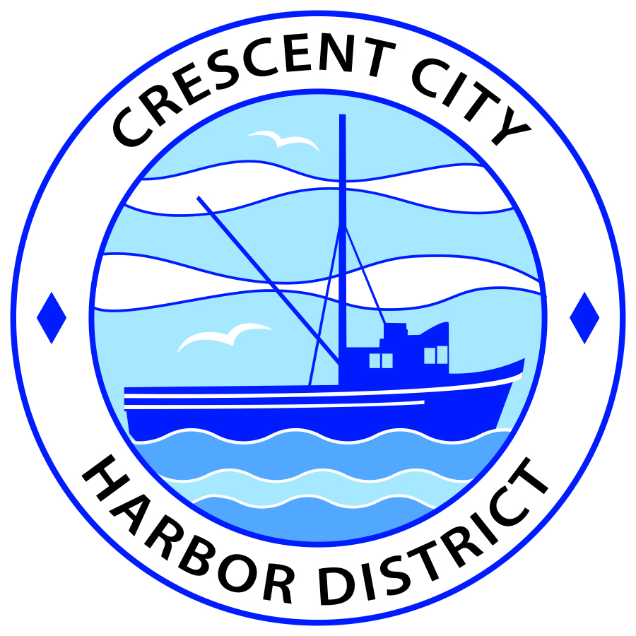
Board of Harbor Commissioners of the Crescent City Harbor District
Ronald A. Phillips, President Patrick A. Bailey, Secretary
James Ramsey, Commissioner Brian L. Stone, Commissioner Wes White, Commissioner

AGENDA
Board of Harbor Commissioners of the Crescent City Harbor District
At the Harbor District Office meeting room
101 Citizens Dock Road, Crescent City, California 95531

Regular Meeting Tuesday, July 18, 2017 4:30 P.M.

The Board of Harbor Commissioners of the Crescent City Harbor District is now meeting in regular session. Only those items that indicate a specific time will be heard at the assigned time. All other items may be taken out of sequence to accommodate the public and staff availability.

4:30 p.m. The Board of Harbor Commissioners will meet in open session to discuss the following agenda items.

Pledge of Allegiance

Public Comment

Public comments are welcomed and encouraged by the Board. The President invites anyone in the audience to speak to the Board of Harbor Commissioners to identify themselves and the matter they wish to discuss. The Harbor Commission will then determine if such matters should be discussed at this time or scheduled for a subsequent meeting. As per the District’s bylaws, each speaker shall be limited to a maximum of three (3) minutes.

Adjourn to Closed Session. The Board of Harbor Commissioners will now meet in closed session to discuss the following items:

- CONFERENCE WITH LEGAL COUNSEL – EXISTING LITIGATION Government Code Section 54956.9 (d) (1) Dutra et al
- CONFERENCE WITH LEGAL COUNSEL – ANTICIPATED LITIGATION (Gov. Code section 54956.9 – two cases): Significant exposure to litigation pursuant to paragraph (2) of subdivision (d) of 54956.9 based on receipt of notices under the Government Claims Act (54956.9(e)(3)). Notices are available for public inspection (54957.5).
- PUBLIC EMPLOYEE PERFORMANCE EVALUATION Government Code Section 54957 Title: CEO/Harbormaster

Report out of Closed Session

- Consent Agenda
Requests to remove items from the Consent Agenda may be heard at this time
- Approval of the warrant list since the June 20, 2017 Harbor Commission Meeting
- Approval of the minutes of the June 20, 2017 Harbor Commission Regular Meeting
- Approval of the minutes of the July 11, 2017 Harbor Commission Special Meeting

- Presentation by Tamera Leighton, Executive Director, Del Norte Local Transportation Commission, on the ‘Commonplace’ Community Engagement Online Tool. Ms. Leighton will update the Harbor Commissioners on community involvement using the ‘Commonplace’ online tool and update the Commission on other current issues

- Presentation by George Williamson, AICP, Executive Officer, Del Norte Local Agency Formation Commission, will address the Harbor Commission on reorganization options. Discuss possible courses of action and direct staff accordingly

- Presentation by Kurt Hochberg, proprietor of Crescent Seafood and Harbor Slip tenant. Mr. Hochberg will update the Commission on his future plans and advise the Commissioners on how they can assist in the process.

- Presentation of 2015-2016 Audited Financial Report to Board of Harbor Commissioners. Review audit report, accept and direct staff

- Presentation of Final Draft on Harbor Tourist serving facilities by Bud Surles Group. Review plan, edit, accept and direct staff to proceed with permitting

- Updated Redwood Harbor Village Park Rules and Regulations. The revised rules and regulations for the Redwood Harbor Village RV Park will be presented to the Board of Harbor Commissioners for their review and approval

- CEO Report

- Commissioner Reports. Reports from Commissioners who represent the Harbor District on the Chamber of Commerce, Tri-Agency, Inter Governmental Relations Committee, Harbor Safety Committee and any other civic or community groups and from any current ad hoc committees

- Board Comments. The Agenda allows Board of Harbor Commission members the opportunity to discuss items of general interest, provide a reference or other resource to staff and to ask for clarification or request staff to report to the Board on certain matters

- Adjournment
*** Adjournment to the Board of Harbor Commissioners meeting scheduled for Tuesday, August 1, 2017 at 5:30 P.M. at the Harbor District Office, 101 Citizens Dock Road, Crescent City, California.

