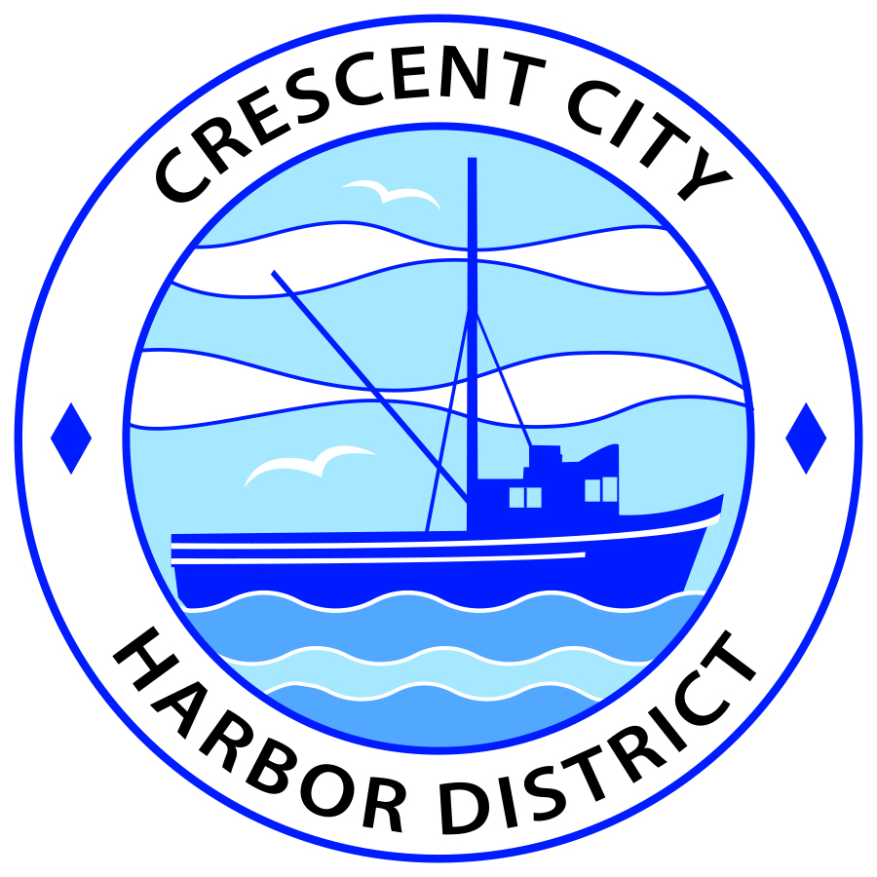
Regular Meeting
Board of Harbor Commissioners of the Crescent City Harbor District
James Ramsey, President Wes White, Secretary
Rick Shepherd, Commissioner Brian L. Stone, Commissioner Carol White, Commissioner

AGENDA

Date: Tuesday, 03 December, 2019

Time: Regular Session: 2:00 p.m.

Place: Crescent City Harbor District Meeting Room
101 Citizens Dock Road, Crescent City, CA 95531

Public participation in this meeting is encouraged and will be accommodated during the public comment period for each item on the agenda. The public will have an opportunity to speak on each item on the Agenda, but will be limited to a comment period of three minutes per item. The public comment period is not intended to be a question and answer session between members of the public and the Commission. The President of the Board of Harbor Commissioners or the Presiding Member of the Board of Harbor Commissioners may enforce, or for good cause extend, the three-minute time limit for each speaker.

Anyone requiring reasonable accommodation to participate in the meeting should contact the Harbor District at 707-464-6174, at least 48 hours prior to the meeting.

All meeting agendas, documents, and other writings (except for privileged documents) that are distributed to a majority of the Commissioners may be inspected by the public at the address listed above. A fee or deposit may be charged for a copy of these public records.

Call to Order

Roll Call

Pledge of Allegiance

Public Comment

This portion of the Agenda allows the public to comment to the Board on any issue not itemized on this Agenda. However, the Board may not take action or engage in discussion on any item that does not appear on the Agenda. Please limit comments to three minutes, and keep in mind that the public will have an opportunity to comment during the separate public comment period for every agenda item.

REGULAR SESSION

- Consent Calendar

All items on this list are considered and acted on in one Motion. Anyone may request an item be removed from the Consent Agenda for separate consideration.
  - Approval of the Warrant List since the 5 November, 2019 Harbor Commission Regular Meeting.

  - Approval of the Minutes of the 19 November, 2019 Harbor Commission Regular Meeting.

- New Business

  - Review and approve the list of items put forth to be surplused
Declare the listed items as surplus property, subject to sale, and direct staff to set a date for the sale of these declared surplus property items pursuant to Harbor District regulations.

- Unfinished Business

- Review the Memorandum of Understanding between Del Norte County and the Harbor District regarding the terms of administration for the Transient Occupancy Tax approved by the voters in Measure C. Review, discuss and approve.

- Set a schedule for the performance review of the CEO/Harbormaster utilizing the review document approved by the Board of Commissioners at the November 19, 2019 Commission meeting.

- American Diversified Energy - 30 Day Notice of Default. Black, Rice & Luna has drafted a document for review and approval.

- Final review and Ratification of Bylaws document. CCHD Bylaws were updated to conform to current California land and new preferences of the Board. Review, discuss, and approve.

- Review of Project List Priorities for Lane Tavasci. Review and discuss priorities of projects prior to his retirement.

- Communications and Reports

  - CEO Report.

  - Financial Report.

  - Commissioner Reports.
Pursuant to the Brown Act, this item allows the Commissioners to briefly discuss activities engaged in since the previous public meeting.

- Adjournment
  - E
Adjournment to the Board of Harbor Commissioners next regular meeting scheduled for Tuesday, January 07, 2020 at 2:00 P.M. at the Harbor District Office, 101 Citizens Dock Road, Crescent City, California.

