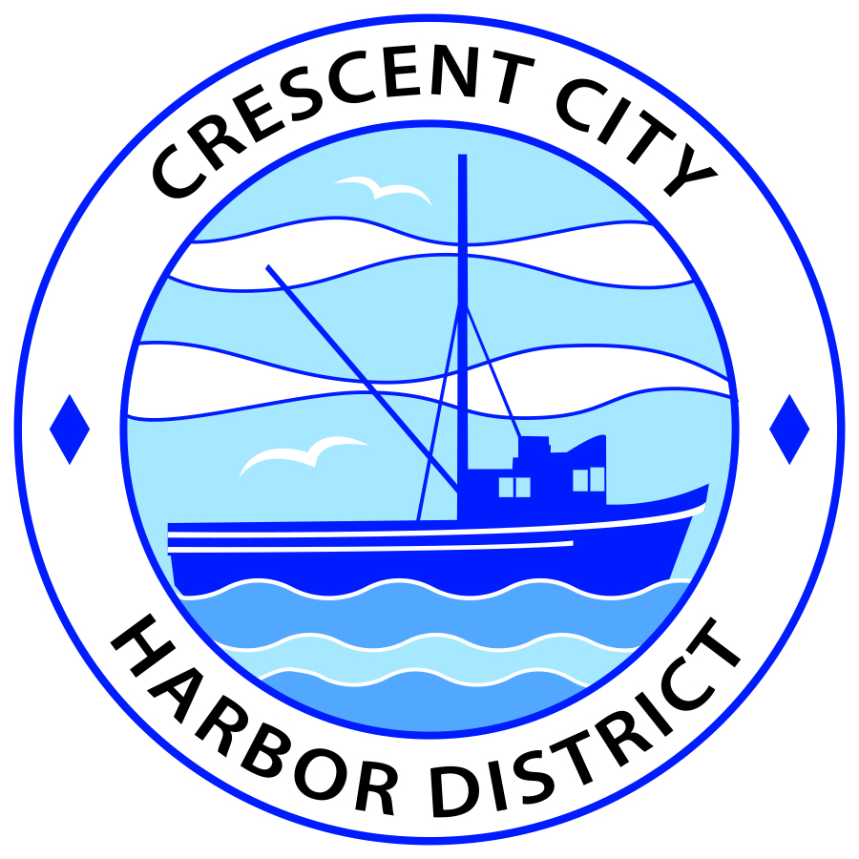
Board of Harbor Commissioners of the Crescent City Harbor District
Patrick A. Bailey, President James Ramsey, Secretary
Ronald A. Phillips, Commissioner Brian L. Stone, Commissioner Wes White, Commissioner
AGENDA
Board of Harbor Commissioners of the Crescent City Harbor District
At the Harbor District Office Meeting Room
101 Citizens Dock Road, Crescent City, California 95531

Regular Meeting Tuesday, April 3, 2018 5:00 P.M.

The Board of Harbor Commissioners of the Crescent City Harbor District is now meeting in regular session. Only those items that indicate a specific time will be heard at the assigned time. All other items may be taken out of sequence to accommodate the public and staff availability.

5:00 p.m. The Board of Harbor Commissioners will meet in open session to discuss the following agenda items.

Pledge of Allegiance

Public Comment

Public comments are welcomed and encouraged by the Board. The President invites anyone in the audience to speak to the Board of Harbor Commissioners to identify themselves and the matter they wish to discuss. The Harbor Commission will then determine if such matters should be scheduled for a subsequent meeting. As per the District’s bylaws, each speaker shall be limited to a maximum of three (3) minutes.

Adjourn to Closed Session: The Board of Harbor Commissioners will now meet in Closed Session to discuss the following item(s):

Closed session:
CONFERENCE WITH LABOR NEGOTIATORS Government Code section 54957.6
Agency Designated Representative Charles Helms to report on negotiations with Carpenters Local Union 751 and Carpenters 46 Northern California Counties Conference Board on 2018-2022 Labor Contract
Report out of Closed Session

- Consent Agenda
Requests to remove items from the Consent Agenda may be heard at this time
- Approval of the warrant list since the March 20, 2018 Harbor Commission Meeting
- Approval of the minutes of the March 20, 2018 Harbor Commission Meeting

- Presentation by American Diversified Energy (ADE) updating the Harbor Commission on Solar Energy Project status. Review and Discuss

- Review Contract Proposal between the Crescent City Harbor District and the Carpenters Local for Harbor Maintenance workers for the four year period covering April 2018 until March 2022. Review and approve

- Review updated Job descriptions. Review, discuss and approve

- Update Harbor Equipment Surplus List. Review list, discuss and approve

- Report from Friends of the Crescent City on status of the Pirate Festival and Pirate Run; need for additional volunteers; and need for additional sponsors. Discuss and share direction

- Discussion of Harbor Debt situation, report on conversations regarding options for addressing debt challenges and options for Harbor fundraising including Citizens Inititaive. Review, discuss strategy and direct staff if action is needed

- CEO Report

- Commissioner Reports. Reports from Commissioners who represent the Harbor District on the Chamber of Commerce, Tri-Agency, Inter Governmental Relations Committee, Harbor Safety Committee and any other civic or community groups and from any current ad hoc committees.

- Board Comments. The Agenda allows Board of Harbor Commission members the opportunity to discuss items of general interest, provide a reference or other resource to staff and to ask for clarification or request staff to report to the Board on certain matters.

- Adjournment
*** Adjournment to the Board of Harbor Commissioners meeting scheduled for Tuesday April 17, 2018 at 5:30 P.M. at the Harbor District Office, 101 Citizens Dock Road, Crescent City, California.

Anyone requiring reasonable accommodation to participate in the meeting should contact the Crescent City Harbor District at 707-464-6174 at least five (5) days prior to the meeting. For TDD use for speech and hearing impaired, please call 707-464-6174 or email tfansler@ccharbor.com with specifics of your request.

