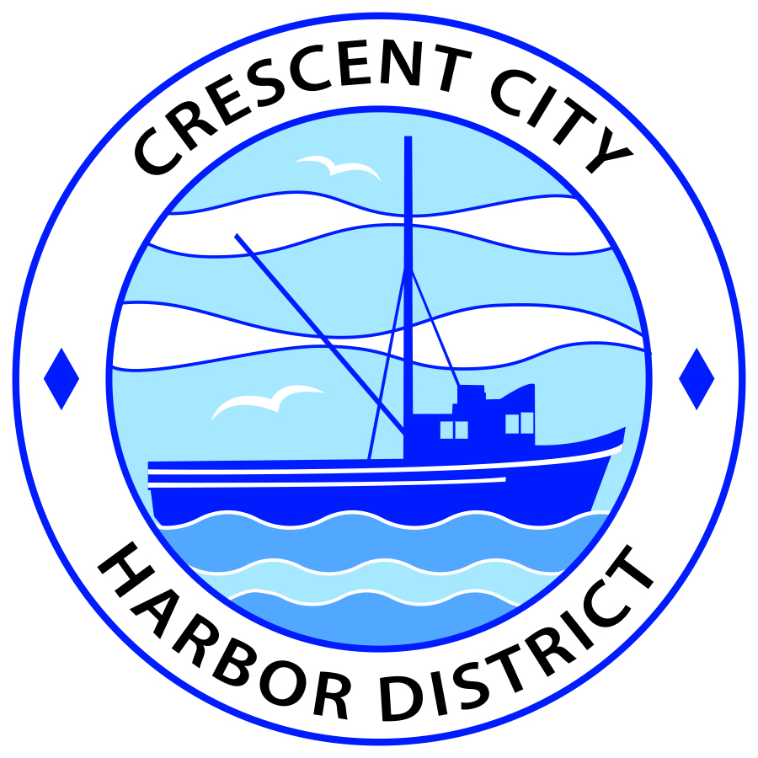
Regular Meeting
Board of Harbor Commissioners of the Crescent City Harbor District
Brian L. Stone, President Carol White, Secretary
James Ramsey, Commissioner; Rick Shepherd, Commissioner; Wes White, Commissioner
AGENDA

Date: Tuesday, 21 January, 2020

Time: Closed Session 2 p.m.
Open Session 2:30 p.m.

Place: Crescent City Harbor District Meeting Room
101 Citizens Dock Road, Crescent City, CA 95531

Public participation in this meeting is encouraged and will be accommodated during the public comment period for each item on the agenda. The public will have an opportunity to speak on each item on the Agenda, but will be limited to a comment period of three minutes per item. The public comment period is not intended to be a question and answer session between members of the public and the Commission. The President of the Board of Harbor Commissioners or the Presiding Member of the Board of Harbor Commissioners may enforce, or for good cause extend, the three-minute time limit for each speaker.

Anyone requiring reasonable accommodation to participate in the meeting should contact the Harbor District at 707-464-6174 x 2 at least 48 hours prior to the meeting.

Call to Order

Roll Call

Pledge of Allegiance

Public Comment

This portion of the Agenda allows the public to comment to the Board on any issue not itemized on this Agenda. However, the Board may not take action or engage in discussion on any item that does not appear on the Agenda. Please limit comments to three minutes, and keep in mind that the public will have an opportunity to comment during the separate public comment period for every agenda item.
Adjourn to Closed Session
- CONFERENCE WITH REAL PROPERTY NEGOTIATORS
Government Code Section 54956.8
APN 117-020-016-000
Agency Negotiator: Charles Helms, CEO/Harbor Master
Negotiating Parties: Summit Development
Under Negotiation: Lease Price and Terms of Payment

- CONFERENCE WITH LEGAL COUNSEL – ANTICIPATED LITIGATION
Government Code Section 54956.9(d)(4): 1 case

Adjourn from Closed Session
Report out of Closed Session
Regular Session
- Consent Calendar

All items on this list are considered and acted on in one Motion. Anyone may request an item be removed from the Consent Agenda for separate consideration.

  - Approval of minutes of the January 7, 2020 Harbor Commission Meeting.

- New Business

  - Approve transfer of Wild Planet/Carvalho hoist lease to South Bend Products, L.L.C. Discuss and approve transfer.

  - 2020 Board of Directors’ Committee assignments for 2020 Calendar Year for the following community Boards and organizations:
    - Tri-Agency
    - Del Norte County/ Crescent City Chamber of Commerce
    - Del Norte County / Crescent City Visitor’s Bureau
    - Crescent City Harbor Safety Committee
    - Intergovernmental Relations Committee (IGRC)

- Unfinished Business

  - Solar PPA Update
  - Status of TOT agreement with Del Norte County

- Communications and Reports

  - CEO Report.
  - Commissioner Reports.
Pursuant to the Brown Act, this item allows the Commissioners to briefly discuss activities engaged in since the previous public meeting.

- Adjournment
  - E
Adjournment to the Board of Harbor Commissioners next regular meeting scheduled for Tuesday, February 04, 2020 at 2 P.M. at the Harbor District Office, 101 Citizens Dock Road, Crescent City, California.

