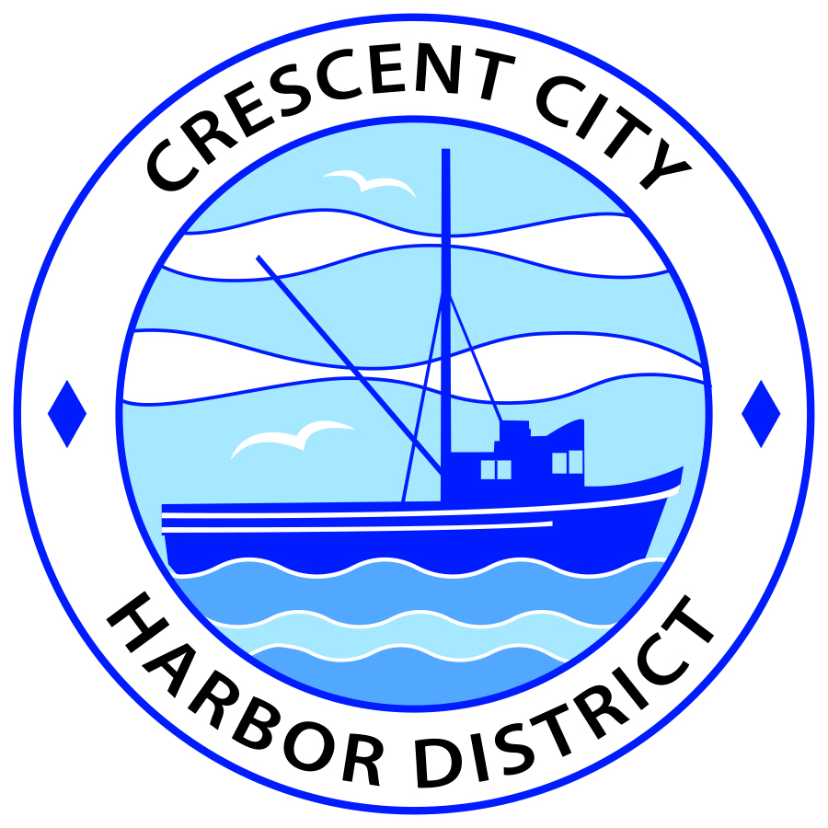
Board of Harbor Commissioners of the Crescent City Harbor District
Ronald A. Phillips, President Patrick A. Bailey, Secretary
James Ramsey, Commissioner Brian L. Stone, Commissioner Wes White, Commissioner

SPECIAL MEETING AGENDA
Board of Harbor Commissioners of the Crescent City Harbor District
At the Harbor District Office meeting room
101 Citizens Dock Road, Crescent City, California 95531

Special Meeting Tuesday, August 17, 2017 5:30 P.M.

The Board of Harbor Commissioners of the Crescent City Harbor District is now meeting in Special session. Only those items that indicate a specific time will be heard at the assigned time. All other items may be taken out of sequence to accommodate the public and staff availability.

5:30 p.m. The Board of Harbor Commissioners will meet in open session to discuss the following agenda items.

Pledge of Allegiance

Public Comment

Public comments are welcomed and encouraged by the Board. The President invites anyone in the audience to speak to the Board of Harbor Commissioners to identify themselves and the matter they wish to discuss. The Harbor Commission will then determine if such matters should be discussed at this time or scheduled for a subsequent meeting. As per the District’s bylaws, each speaker shall be limited to a maximum of three (3) minutes.

- Consent Agenda
Requests to remove items from the Consent Agenda may be heard at this time
- Approval of the warrant list since the August 1, 2017 Harbor Commission Meeting
- Approval of the minutes of the August 1, 2017 Harbor Commission Regular Meeting

- Presentation of the Final version of the Crescent City RV Resort plan by Bud Surles Consulting Group. Review, comment, approve and direct staff accordingly

- Presentation of delinquent uncollectible accounts. Review accounts and reason why they are uncollectible and direct staff on how to proceed.

- Presentation of letter by Commissioner Brian L. Stone requesting assistance for Sen. McGuire. Review letter, discuss and proceed accordingly

- Presentation by the Executive Director of the Northcoast Marine Mammal Center requesting permission for their fundraising run to utilize Harbor District property. Review data, discuss, approve and direct staff accordingly

- CEO Report

- Commissioner Reports. Reports from Commissioners who represent the Harbor District on the Chamber of Commerce, Tri-Agency, Inter Governmental Relations Committee, Harbor Safety Committee and any other civic or community groups and from any current ad hoc committees

- Board Comments. The Agenda allows Board of Harbor Commission members the opportunity to discuss items of general interest, provide a reference or other resource to staff and to ask for clarification or request staff to report to the Board on certain matters

- Adjournment
*** Adjournment to the Board of Harbor Commissioners meeting scheduled for Tuesday, September 5, 2017 at 5:30 P.M. at the Harbor District Office, 101 Citizens Dock Road, Crescent City, California.

