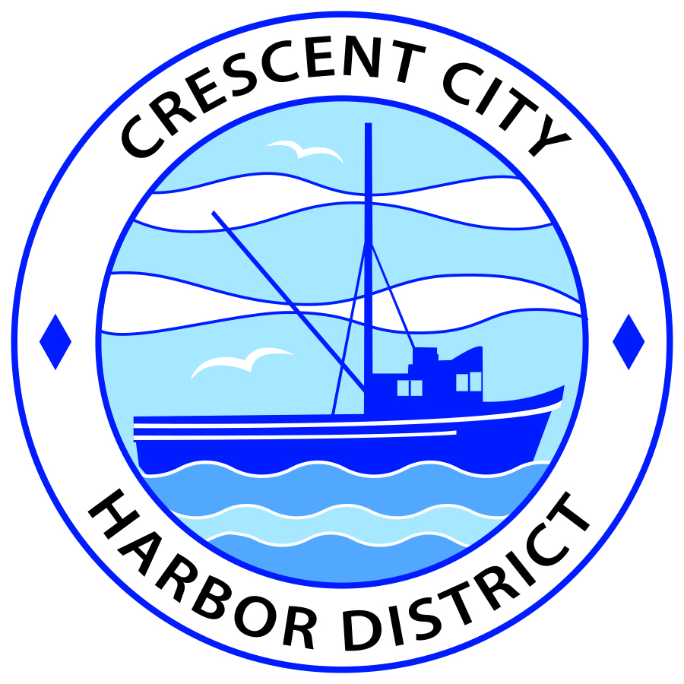
Board of Harbor Commissioners of the Crescent City Harbor District
Patrick A. Bailey, President James Ramsey, Secretary
Ronald A. Phillips, Commissioner Brian L. Stone, Commissioner Wes White, Commissioner
SPECIAL AGENDA

Date: Wednesday, December 5, 2018

Time: Special Session – 3:30 p.m.

Place: Crescent City Harbor District Meeting Room
101 Citizens Dock Road, Crescent City, CA 95531

Public participation in this meeting is encouraged and will be accommodated during the public comment period for each item on the agenda. The public will have an opportunity to speak on each item on the Agenda, but will be limited to a comment period of three minutes per item. The public comment period is not intended to be a question and answer session between members of the public and the Commission. The President of the Board of Harbor Commissioners or the Presiding Member of the Board of Harbor Commissioners may enforce, or for good cause extend, the three-minute time limit for each speaker.

Anyone requiring reasonable accommodation to participate in the meeting should contact the Harbor District at 707-464-6174 x 2 at least 48 hours prior to the meeting.

- Call to Order

- Roll Call

- Pledge of Allegiance

- Closed Session – N/A

- Reconvene to Regular Session – N/A

- Report out of Closed Session – N/A

- Public Comment

This portion of the Agenda allows the public to comment to the Board on any issue not itemized on this Agenda. However, the Board may not take action or engage in discussion on any item that does not appear on the Agenda. Please limit comments to three minutes, and keep in mind that the public will have an opportunity to comment during the separate public comment period for every agenda item.
- Consent Calendar – N/A

- New Business – N/A

- Unfinished Business

  - Review and approve Amendment No. 1 to the Solar Energy Power Purchase and License Agreement, direct President to sign.

Summary: At the November 20, 2018 meeting of the Board of Harbor Commissioners, staff presented an amendment whereby time for installation of the System would be extended for one year. Commissioners’ consensus was that a one-year extension was too long, and directed staff to negotiate a shorter extension. Staff has negotiated a six-month extension and presents that Amendment at this Special meeting of the Board of Harbor Commissioners.
Recommendation: Move to approve Amendment No. 1 to the Solar Energy Power Purchase Agreement and direct the President to sign.
- Communications and Reports – N/A

- Adjournment
  - E
Adjournment to the Board of Harbor Commissioners next regular meeting scheduled for Tuesday, December 18, 2018 at 5:30 P.M. at the Harbor District Office, 101 Citizens Dock Road, Crescent City, California.

