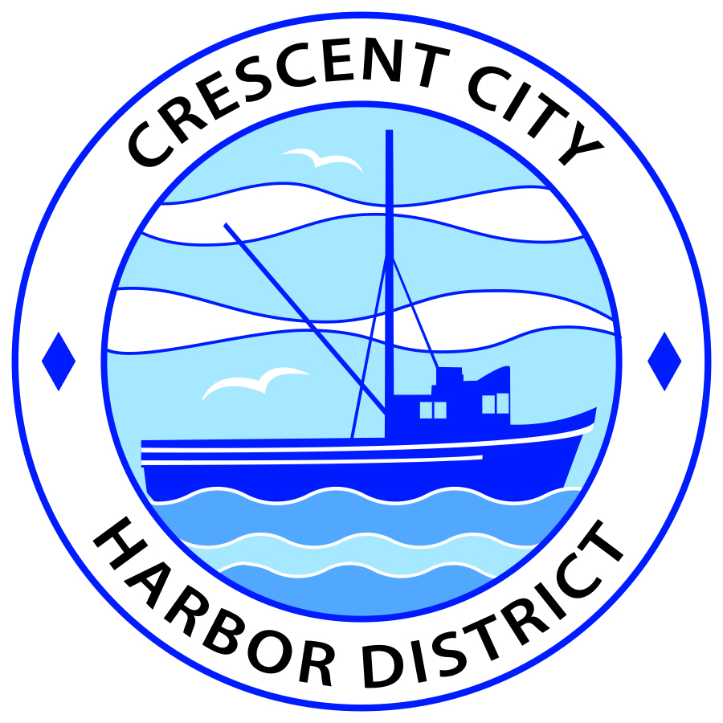
Board of Harbor Commissioners of the Crescent City Harbor District
Patrick A. Bailey, President James Ramsey, Secretary
Ronald A. Phillips, Commissioner Brian L. Stone, Commissioner Wes White, Commissioner
AGENDA
Board of Harbor Commissioners of the Crescent City Harbor District
At the Harbor District Office Meeting Room
101 Citizens Dock Road, Crescent City, California 95531

Regular Meeting Tuesday, 2 October, 2018 5:30 P.M.

The Board of Harbor Commissioners of the Crescent City Harbor District is now meeting in regular session. Only those items that indicate a specific time will be heard at the assigned time. All other items may be taken out of sequence to accommodate the public and staff availability. Anyone requiring reasonable accommodation to participate in the meeting should contact the Harbor District at 707-464-6174 x 2 at least five (5) days prior to the meeting.

5:30 p.m. The Board of Harbor Commissioners will meet in open session to discuss the following agenda items.

Pledge of Allegiance

Public Comment

Public comments are welcomed and encouraged by the Board. The President invites anyone in the audience to speak to the Board of Harbor Commissioners to identify themselves and the matter they wish to discuss. The Harbor Commission will then determine if such matters should be scheduled for a subsequent meeting. As per the District’s bylaws, each speaker shall be limited to a maximum of three (3) minutes.

Adjourn to Closed Session

CONFERENCE WITH LEGAL COUNSEL – ANTICIPATED LITIGATION

Initiation of litigation pursuant to paragraph (4) of subdivision (d) of Section 54956.9:
Conference with Legal Counsel Cruz Hernandez v. Bountiful Oceans, Inc. Northern District Case No.: 4:17-cv-03625-JSW
Crescent City Harbor District v. Dutra et al. Sacramento Superior Court Case No.: 34-2017-00215044-CU-BC-GDS
Crozier v. Crescent City Harbor District Del Norte Superior Court Case No.: CVPI-2018-1194

Report Out of Closed Session
- Consent Agenda
Requests to remove items from the Consent Agenda may be heard at this time
- Approval of the warrant list since the 18 September, 2018, Harbor Commission Meeting
- Approval of the minutes of the 18 September, 2018 Harbor Commission Meeting

- Cancel or re-schedule the 16 October 2018 Harbor Commission. Discuss and approve

- Eileen Cooper will present information on tsunami evacuation. Ms. Cooper was authorized by the Harbor Commission to present information on tsunami evacuation

- Discussion about researching the possibility of hosting the Visitors Bureau Information center at 201 Citizens Dock Road. Discussion about mechanics of preparing the old Englund Marine building in advance of extending an invitation to the Visitors Bureau to operate a facility at the Harbor District

- Appoint Ad Hoc Committee to discuss proposal from Captain Shon to lease the Old Englund Marine Building at 201 Citizens Dock. Choose Commissioners to serve on Ad Hoc Committee to discuss proposal for a restaurant at 201 Citizens Dock Road

- Appoint Ad Hoc Committee to discuss proposal from North Coast Ocean Sports and Grill. North Coast Ocean Sports and Grill is requesting a lease modification

- Appoint an Ad Hoc Committee from the Board of Harbor Commissioners to discuss transfer of 160 Anchor Way lease. Current tenant wishes to transfer lease to new operator

- Choose a Harbor Commissioner to serve as a single point of contact for outside groups and agencies. Appoint a Harbor Commissioner to serve as the single point of contact for outside agencies and groups so that there is a single message being shared by the Harbor District Commissioners

- Update on the progress of the solar energy project. Deputy Harbor Master Lane Tavasci will update the Board of Harbor Commissioners on the solar project

- Update on the progress of the Citizens Initiative addressing the Harbor District debt situation. Listen to presentation and Discuss

- Discussion of Harbor District debt situation and options for fundraising to meet debt challenge. Review, discuss strategy and direct staff if action is needed

- CEO Report

- Commissioner Reports. Reports from Commissioners who represent the Harbor District on the Chamber of Commerce, Tri-Agency, Inter Governmental Relations Committee, Harbor Safety Committee and any other civic or community groups and from any current ad hoc committees.

- Board Comments. The Agenda allows Board of Harbor Commission members the opportunity to discuss items of general interest, provide a reference or other resource to staff and to ask for clarification or request staff to report to the Board on certain matters.

- Adjournment
*** Adjournment to the Board of Harbor Commissioners next regular meeting scheduled for Tuesday 20 November, 2018 at 5:30 P.M. at the Harbor District Office, 101 Citizens Dock Road, Crescent City, California.

