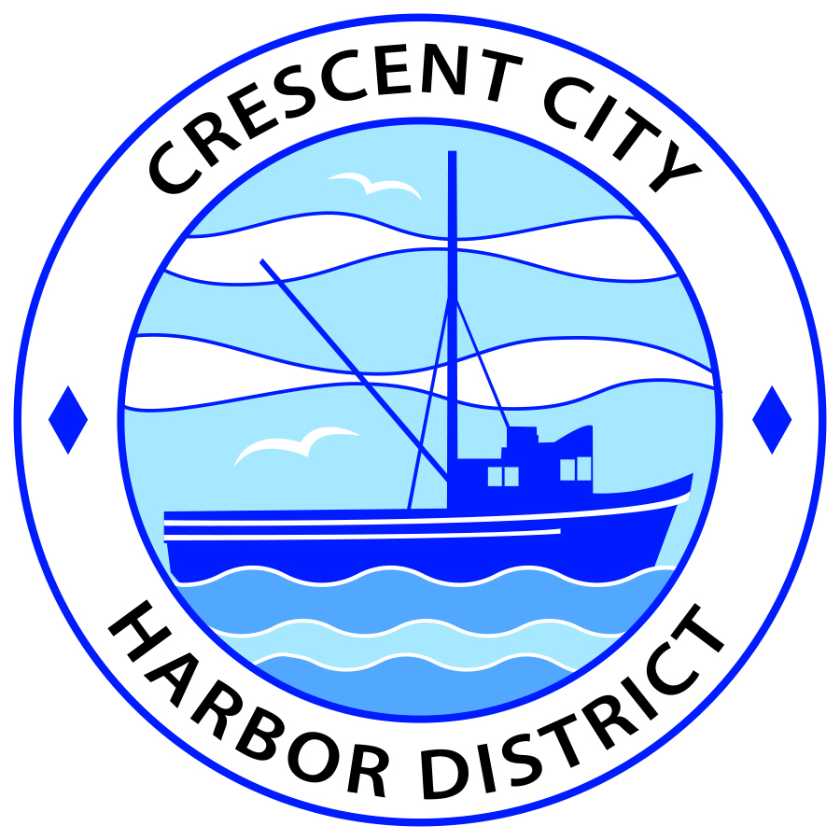
Regular Meeting
Board of Harbor Commissioners of the Crescent City Harbor District
James Ramsey, President Wes White, Secretary
Rick Shepherd, Commissioner Brian L. Stone, Commissioner, Carol White, Commissioner
AGENDA

Date: Tuesday, 24 September, 2019

Time: Closed Session: 2:00 p.m.
Regular Session: 2:30 p.m.

Place: Crescent City Harbor District Meeting Room
101 Citizens Dock Road, Crescent City, CA 95531

Public participation in this meeting is encouraged and will be accommodated during the public comment period for each item on the agenda. The public will have an opportunity to speak on each item on the Agenda, but will be limited to a comment period of three minutes per item. The public comment period is not intended to be a question and answer session between members of the public and the Commission. The President of the Board of Harbor Commissioners or the Presiding Member of the Board of Harbor Commissioners may enforce, or for good cause extend, the three-minute time limit for each speaker.

Anyone requiring reasonable accommodation to participate in the meeting should contact the Harbor District at 707-464-6174 x 2 at least 48 hours prior to the meeting.

Call to Order

Roll Call

Pledge of Allegiance

Public Comment

This portion of the Agenda allows the public to comment to the Board on any issue not itemized on this Agenda. However, the Board may not take action or engage in discussion on any item that does not appear on the Agenda. Please limit comments to three minutes, and keep in mind that the public will have an opportunity to comment during the separate public comment period for every agenda item.
Closed Session
REAL PROPERTY NEGOTIATORS
CONFERENCE WITH REAL PROPERTY NEGOTIATORS
Government Code Section 54956.8
Property: APN 117-180-021-000
Agency Negotiator: Charlie Helms CEO/Harbor Master
Negotiating Parties: Summit Development Corporation
Under Negotiation: Price and Terms of Commercial Lease

Report out of closed session.

Regular Session

- Consent Calendar

All items on this list are considered and acted on in one Motion. Anyone may request an item be removed from the Consent Agenda for separate consideration.
  - Approval of the warrant list since the 20 August, 2019 Harbor Commission Meeting

  - Approval of the minutes of the 20 August, 2019 Harbor Commission Meeting

  - Approval of the minutes of the 20 August, 2019 Harbor Commission Special Meeting

- New Business

  - Consider revisions to the draft agreement with the County of Del Norte regarding the Transient Occupancy Tax. Staff has drafted revisions that more closely mirror the text of the Measure “C” citizens ballot initiative. Review and discuss.

  - Consider a draft Harbor Facilities Plan as required by Measure C. Review, discuss, and approve.

  - Consider a revised Travel Policy. Staff has drafted a revised policy that is more comprehensive and conforms with current IRS and California Government Code requirements. Review, discuss, and approve.

  - Removal of “Christie R.” Consider the proposal of Global Diving and Salvage, Inc., to perform a demolition and recycling of entire vessel. Many other vendors have been contacted since 2011 but have declined to bid on the project.

  - Review a request for audit services. Staff has prepared an RFP. Staff proposes a 5-year contract with the right to renew. Review, discuss, and approve.

  - Assembly Bill 1184 (Gloria)- Staff has prepared letter to be approved by the board to be sent to Governor Newsom requesting that he Veto Assembly Bill 1184(Gloria). Review, discuss and approve.

- Communications and Reports

  - Financial Report.

  - CEO Report.

  - Commissioner Reports.
Pursuant to the Brown Act, this item allows the Commissioners to briefly discuss activities engaged in since the previous public meeting.

- Adjournment
  - E
Adjournment to the Board of Harbor Commissioners next regular meeting scheduled for Tuesday, October 1, 2019 at 2:00 P.M. at the Harbor District Office, 101 Citizens Dock Road, Crescent City, California.

