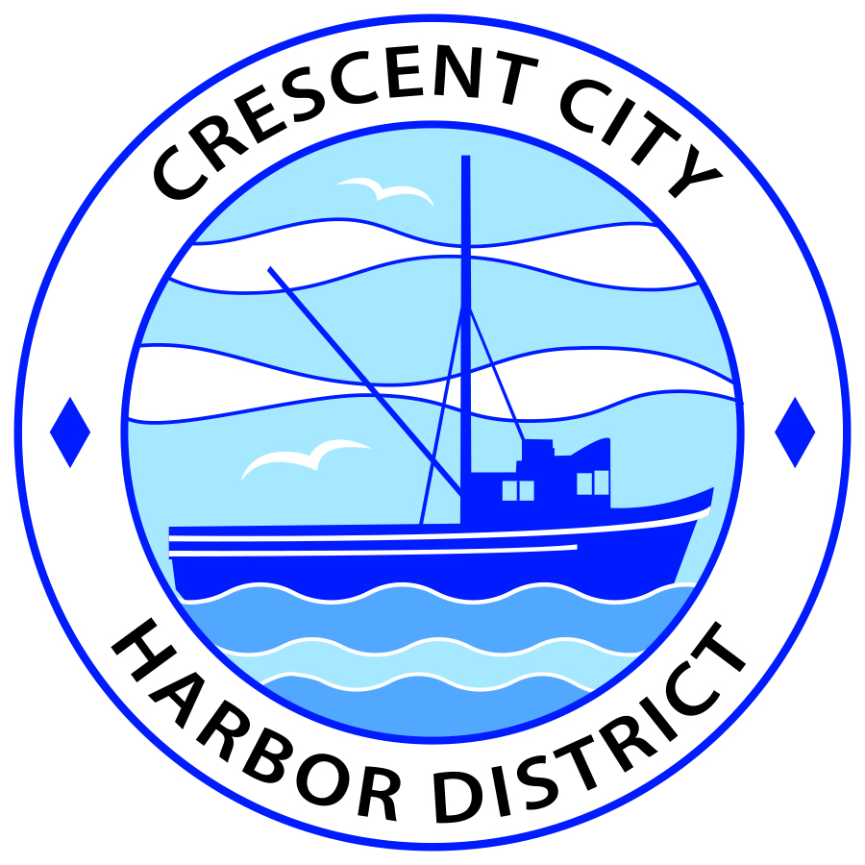
Board of Harbor Commissioners of the Crescent City Harbor District
Ronald A. Phillips, President Patrick A. Bailey, Secretary
James Ramsey, Commissioner Brian L. Stone, Commissioner Wes White, Commissioner

AGENDA
Board of Harbor Commissioners of the Crescent City Harbor District
At the Harbor District Office meeting room
101 Citizens Dock Road, Crescent City, California 95531

Special Meeting Friday, May 26, 2017 Noon

The Board of Harbor Commissioners of the Crescent City Harbor District is now meeting in regular session. Only those items that indicate a specific time will be heard at the assigned time. All other items may be taken out of sequence to accommodate the public and staff availability.

Noon The Board of Harbor Commissioners will meet in open session to discuss the following agenda item.

Pledge of Allegiance

Public Comment

Public comments are welcomed and encouraged by the Board. The President invites anyone in the audience to speak to the Board of Harbor Commissioners to identify themselves and the matter they wish to discuss. The Harbor Commission will then determine if such matters should be discussed at this time or scheduled for a subsequent meeting. As per the District’s bylaws, each speaker shall be limited to a maximum of three (3) minutes.

- Update the Harbor Commission and the Community on the progress made toward the Harbor District management of Redwood Harbor Village. Introduce new staff members who will be working in the RV Park and share the task list for opening and operating the Park under Harbor Management.

- Board Comments. The Agenda allows Board of Harbor Commission members the opportunity to discuss items of general interest, provide a reference or other resource to staff and to ask for clarification or request staff to report to the Board on certain matters

- Adjournment
*** Adjournment to the Board of Harbor Commissioners meeting scheduled for Tuesday, June 6, 2017 at 5:30 P.M. at the Harbor District Office, 101 Citizens Dock Road, Crescent City, California.

