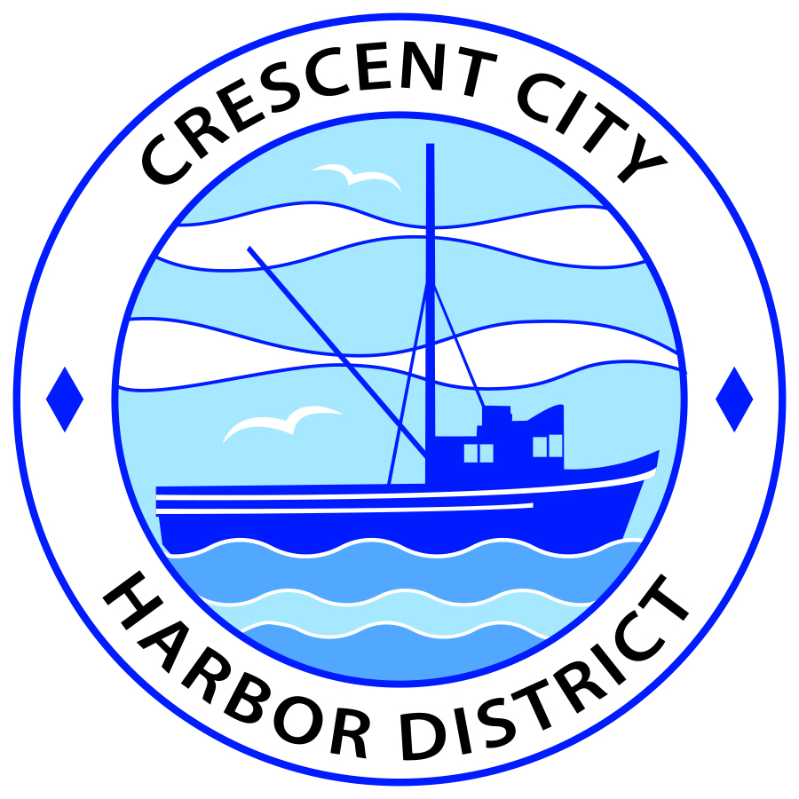
Regular Meeting
Board of Harbor Commissioners of the Crescent City Harbor District
James Ramsey, President Wes White , Secretary
Rick Shepherd, Commissioner Brian L. Stone, Commissioner, Carol White, Commissioner
AGENDA

Date: Tuesday, January 22, 2019

Time: 5:30 p.m.

Place: Crescent City Harbor District Meeting Room
101 Citizens Dock Road, Crescent City, CA 95531

Public participation in this meeting is encouraged and will be accommodated during the public comment period for each item on the agenda. The public will have an opportunity to speak on each item on the Agenda, but will be limited to a comment period of three minutes per item. The public comment period is not intended to be a question and answer session between members of the public and the Commission. The President of the Board of Harbor Commissioners or the Presiding Member of the Board of Harbor Commissioners may enforce, or for good cause extend, the three-minute time limit for each speaker.

Anyone requiring reasonable accommodation to participate in the meeting should contact the Harbor District at 707-464-6174 x 2 at least 48 hours prior to the meeting.

Call to Order

Roll Call

Pledge of Allegiance

Public Comment

This portion of the Agenda allows the public to comment to the Board on any issue not itemized on this Agenda. However, the Board may not take action or engage in discussion on any item that does not appear on the Agenda. Please limit comments to three minutes, and keep in mind that the public will have an opportunity to comment during the separate public comment period for every agenda item.
- Consent Calendar

All items on this list are considered and acted on in one Motion. Anyone may request an item be removed from the Consent Agenda for separate consideration.
  - Approval of the warrant list since the January 7, 2019 Harbor Commission Meeting
  - Approval of the minutes of the January 7, 2019 Harbor Commission Meeting

- New Business

  - Discuss and Direct Staff on Implementation of the Strategic Plan. The Board will specifically discuss and direct staff regarding only the following items from “Goal IV: Increase Tourism” of the Crescent City Harbor District’s Strategic Plan:
    - Strategy I - Task 2: Upgrade Old Englund Marine building as hub for partnering organizations.
    - Strategy III - Task 1: Design and install signage to be compatible with the existing character of the Harbor.
    - Strategy III - Task 2: Assess the ‘clutter’ of signs near the Harbor entrance on Highway 101 north and south. Place new monument/sign for maximum traveler sight.
    - Strategy III - Task 4: Develop Harbor visitor map.
    - Strategy IV - Task 1: Work with local non-profits and other organizations to encourage the use of Harbor properties for their events.
  - Review, discuss, and adopt Resolution 2019-01. Resolution 2019-01 adopts the appropriate portions of the Del Norte County Local Hazard Mitigation Program.

- Unfinished Business

  - Approval of the warrant list from December 18, 2018 to January 7, 2019. The warrant list was removed from the consent calendar and tabled from the previous meeting on January 7, 2019.
  - Discuss and direct staff on placement of the Wooden Whale. The Wooden Whale has been in storage and it is time to decide on a new location for the Whale. Several locations have been explored and photographs of those locations are included in the agenda packet.
  - Update on “Crescent City” Signage on Anchor Way. Benches, picnic tables, and other improvements have been made to Anchor Way in front of the “Crescent City” sign.

  - January 17, 2019 Photographs of Storm damage “King Tide” and Heavy Storm. Pictures taken by Deputy Harbormaster Lane Tavasci of the storm debris/damage along Anchor Way.

- Communications and Reports

  - CEO Reports.
  - Commissioner Reports.
Pursuant to the Brown Act, this item allows the Commissioners to briefly discuss activities engaged in since the previous public meeting.
- Adjournment
  - E
Adjournment to the Board of Harbor Commissioners next regular meeting scheduled for Tuesday, February 5, 2019 at 5:30 P.M. at the Harbor District Office, 101 Citizens Dock Road, Crescent City, California.

